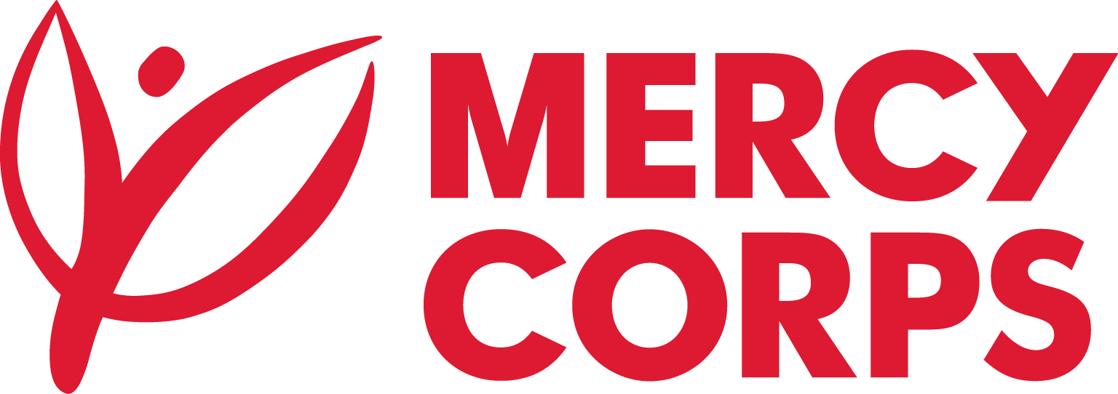
Date: 07- May-2024
Reference: RFB-KBL 00-03
Tender Notice
Mercy Corps is a non-religious, non-profit and non-governmental international humanitarian organization.

Mercy Corps intends to purchase 2-3 Vehicles (New or 2-3 years old model without plate) for its operational use in Afghanistan.

If you are interested in submitting a bid, you will need to complete an Intent to Bid and Supplier Information Forms and submit them according to the guidelines below:
- The suppliers can download the Intent to Bid and Supplier Information Forms on this website link https://www.acbar.org/site-rfq or www.mercycorps.org/tenders

- Intend to Bid Form can be picked up at Mercy Corps office:

- Kabul: House # 31, Herati Masjid Street, Shar-e-Naw.
- Herat: House # 34, Herat university road, District No # 01
- Kandahar: House # 54, Street S, Road 2, Aino Maina.
Completed Intent to Bid and Supplier Information Forms must be submitted to Mercy Corps by 12 May 2024 in one of the below methods:
- Email completed Intent to Bid and Supplier Information Forms to af-tender@mercycorps.org with the Tender Reference number in the email subject line.

- Return completed Intent to Bid and Supplier Information Forms in person and put in the Tender Box placed at Mercy Corps office Kabul, Kandahar and Herat. The Tender Reference number should be written in the envelope.
After the closing date of this Tender Notice, the Request for Proposal will be sent to the suppliers who submitted Intent to Bid Forms. The Request for Proposal will be sent according to the preference you have mentioned in the Intent to Bid Form.

