
Reference: PAK/ISD/0022-2024

Tender Notice
Mercy Corps is a non-religious, non-profit and non-governmental international humanitarian organization.

Mercy Corps is seeking a service provider(s) for Complete Servicing, Maintenance and Troubleshooting of Shimadzu x-ray machines across Pakistan.

If you are interested in submitting a bid, you will need to complete an Intent to Bid (ITB) and Supplier Information Form (SIF) submit it according to the guidelines below:
- The suppliers can download the Intent to Bid and Supplier Information
Form on this link https://bit.ly/pk2224 or QR code.
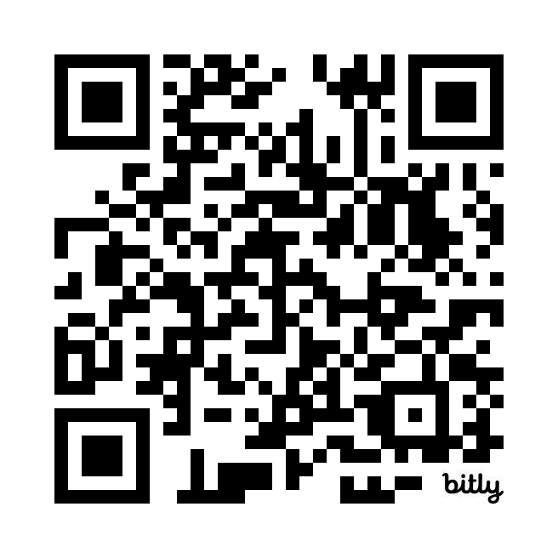

- Intend to Bid and Supplier Information Form can be picked up at Mercy Corps office Plot# 189/190, Street# 6, Sector I-9/2, Islamabad.
Completed ITB and SIF must be submitted to Mercy Corps by May 4, 2024, 11:45 pm in one of the below methods.
- Email completed Intent to Bid and Supplier Information Form to islamabaditb@mercycorps.org with the Tender Reference number in the email subject line.

- Return completed Intent to Bid and Supplier Information Form in person and put in the Tender Box placed at Mercy Corps office on above mentioned address. The Tender Reference number should be written in the envelope.
After the closing date of this Tender Notice, the Request for Proposal will be sent to the consultants/firms who submitted ITB along with SIF. The Request for Proposal will be sent according to the preference you have mentioned in the Intent to Bid Form.
Intent to Bid does not constitute any transactional obligation between Mercy Corps and the intended offeror.

