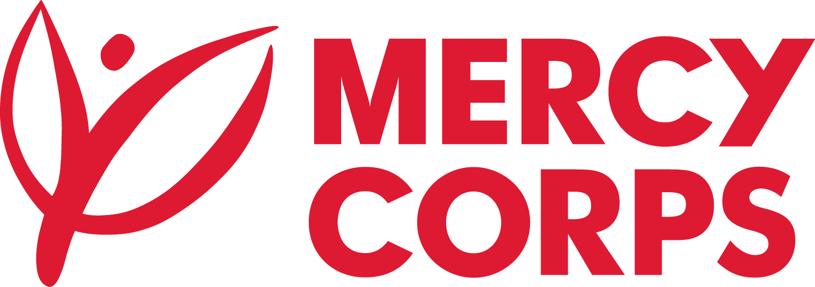
Date: April 2024
Reference No.: ET01/PR124494/2024

Tender Notice
Mercy Corps is a non-religious, non-profit and non-governmental international humanitarian organization.

Mercy Corps is seeking a supplier to supply and Installation of: Supply and Installation of Chlorine Dosing Machine for Boreholes Water Schemes Located in four region such as
Konso Zone/SNNPR/, Aba’ala Zone/Afar/, Negelle Borena/Oromia Region/ and Denan, Gode Zone/Somali Region/.

If you are interested in submitting a bid, you should complete an Intent to Bid plus Supplier Information Forms and then, submit it according to the guidelines below.
- Suppliers can download the Intent to Bid and Supplier Information Forms from www.mercycorps.org/tenders
OR
- Intend to Bid Form can be picked up from Mercy Corps Addis Ababa office Yeka Sub-City, Kebele 08, House No. 377; Hayahulet, Tel. 011-1-110777

- Bidders can send email to et-tender-questions@mercycorps.org and request the Intent to bid form.
Completed Intent to Bid and Supplier Information Forms must be submitted to Mercy Corps till 15th April, 2024 5:00PM in one of the below methods.
- Email completed Intent to Bid and Supplier Information Forms to et-tender-questions@mercycorps.org with the Tender Reference number in the email subject line.
OR

- Return the completed Intent to Bid and Supplier Information Forms in person and put in the Tender Box placed at Mercy Corps Addis Ababa office Yeka Sub-City, Kebele 08, House No. 377; Hayahulet. The Tender Reference number should be written on the envelope.
After the closing date of this Tender Notice, the Request for Bid will be sent to the suppliers who submitted Intent to Bid Forms. The Request for Bid will be sent according to the preference you have mentioned in the Intent to Bid Form.

