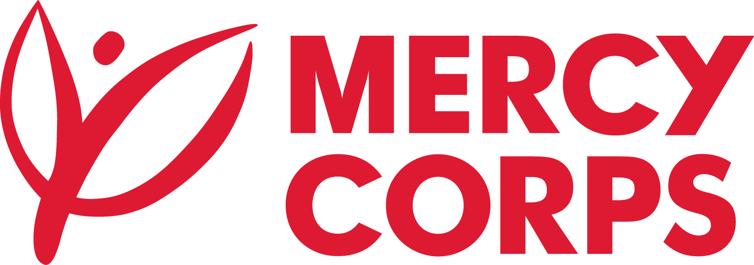
Date: 17 March 2024
Reference: PR123058
Tender Notice
Mercy Corps is a non-religious, non-profit and non-governmental international humanitarian organization.

Mercy Corps is seeking a qualified and registered and authorized educational service providers to submit Intent to Bid form, for The Non-Formal Education Component of the Positive Youth Engagement (PYE) activities. The service aims to identify service provider(s) specialized in delivering non-formal activities, learning materials customization in English language, Math, and Science subject areas, and capacity building initiative to youth in grades 7-12 from at-risk communities.

If you are interested in submitting a bid, you will need to complete an Intent to Bid Form and submit it according to the guidelines below:
- The suppliers can download the Intent to Bid Form on this link https://docs.google.com/document/d/1_T7kzL62Bac_uSHmXEvEuS1vxsVOMo-a/edit?usp=sharing&ouid=102512250464012461503&rtpof=true&sd=true

- Intend to Bid Form can be picked up at Mercy Corps office in Ramallah, Al Bardouni Building, Procurement office, 5th Floor.
Completed Intent to Bid Forms must be submitted to Mercy Corps by 24 March 2023, before 13:00 in one of the below methods.
- Email completed Intent to Bid Form to ps-tender@mercycorps.org with the Tender Reference number in the email subject line [ITB - PR123058]

- Return completed Intent to Bid Form in person and put in the Tender Box placed at Mercy Corps office Ramallah, Al Bardouni Building, Procurement office, 5th Floor. The Tender Reference number should be written in the envelop.
After the closing date of this Tender Notice, the Request for Proposal will be sent to the service providers who submitted Intent to Bid Forms. The Request for Proposal will be sent according to the preference you have mentioned in the Intent to Bid Form.

