E-Learning course- Seed System Security Assessment + Response January 3 2023

Suggested changes for course revision

Module # | Type of change | Exact Description of change
OVERALL | BROAD ISSUE TO DISCUSS. ALSO WITH DESIGNER
Scoring | Add scoring system | To discuss scoring. Each question with the same value  Maybe just score on end of module questions  (also because internal questions are not always clear cut (partially incorrect; partially correct)
Certificate at end | new | Add certificate of COMPLETION of course. (not certification of excellence- just Certificate of completion of course. Designer to design)
ADD- General Resource List | new | Can adapt from SERT
ADD: ACRONYM LIST | new | Can adapt from SERT
Add Glossary list |  | This could be added?
Tools/buttons or links | Links to specific tools | Should we use ‘buttons’ tied direct downloads- or links to the seedsystem website. (or both- direct downloads and links to SeedSystem. I suggest both. So direct download button and also a link to SeedSystem.  (sperling will need to send updated links for all links in the course)
Check compatibility of devices |  | Check for mobile compatibility- A
Quizzes, internal | Ability to redo? | There are two kinds of ‘quizzes’—  At the end of each Module- which serve as the basic scoring system for course  Then, there are internal quizzes in some of the modules- like the drags and drops. For the internal quiz questions, is it possible to build in the function for the participant to be able to ‘re-do’ these, if he/she wants to try again?
Review stylistic elements |  | Designer to review for consistency of colors, text sizes, fonts, use of bold, etc. There are many current variations
Module 1
DISASTERS  intor | Text change | Current:  Official figures on disasters worldwide show them to be on the increase in terms of numbers, but also in terms of complexity.  Here are some facts shared by the USAID Office of US Foreign Disaster Assistance:  Change to  Official figures on disasters worldwide show them to be on the increase in terms of numbers, but also in terms of complexity.  Here are some facts shared by the USAID Bureau for Humanitarian Assistance (BHA)
Disaster figures. (flip card of Haiti destroyed building image | Data change/text change | Current text: The USAID OFDA responded to 52 disasters in FY 2016  Changes requested. The USAID BHA responded to 356 disasters linked to agriculture in FY 2023
Flip card of Drought/road image | Data change/  Text change | Current text: This included floods, drought, cases of deep food insecurity, but most of the 52 were complex emergencies (multiple stresses, 2 or 3 at once) e.g. war plus drought.  Changes requested:  This included floods, drought, earthquakes , cases of deep food insecurity, but most (N=216) were complex emergencies (multiple stresses, 2 or 3 at once) e.g. war plus drought.
Flip card of man sorting maize seed | Data change | Current text: For agriculture alone, USAID OFDA spent $US 72 million in this single FY 2016.  Change requested.  Of these, 96 awards (or over 25% of all) focused specifically on seed/seedlings for an approximate value of X million
Seed-related interventions- the timeline | Text change | Timeline of interventions. The 2016 tab  Current text: The most recent year, FAO, alone, had seed projects in 76 countries and most of which were mostly in response to emergencies.  Change to: In 2016, FAO alone, had seed projects in 76 countries, most of which were mostly in response to emergencies.
Seed-related interventions. The time line | Add to timeline diagram (after 2016) | Add year and number. Most recent figures… FAO  - 2022 c.170 projects, valued over US $500m
Repetitive seed aid | Data change | Current. Ethiopia 43+ years  Change to Ethiopia 45+ years
Repetitive seed aid | Summary section | Current text.  In summary  Ethiopia has the record of 43+ years with continuous aid, but places like Burundi are not far behind.  Are we effective? Can we do better? Do we really understand the seed security situation on hand? We come back to the issue of assessments and the reason for seed system security assessments.  Change to  In summary  Ethiopia has the record of 45+ years with continuous aid, but many places also experience repeated aid delivery.  Are we effective? Can we do better? Do we really understand the seed security situation on hand? We come back to the issue of assessments and the rationale for seed system security assessments.
Assumptions | Title change | Examining Assumptions
Assumptions  (Examining Assumptions) | Text change | Current text  In summary  If a farmer uses 12 kgs sorghum seed, in a bad year she yields just 260kg.  She needs 5% of her harvest to have enough seed. So her harvest can fail 95% and she still has seed. Food problem? Yes. Seed problem? Probably not.  A harvest shortfall is not equal ≠ to seed shortfall.  Change to;  If a farmer uses 12 kgs sorghum seed, in a bad year, she reaps just 260kg.  She needs 5% of her harvest to have enough seed. So her harvest can fail 95% and she still has seed. Food problem? Yes. Seed problem? Probably not.  A harvest shortfall is not equal (≠) to seed shortfall.
TEST at end | Change in numbering  Adding a missing question  Deleting one of the current questions | Current state. There are questions numbered to 6 (but question 3 is missing. So the current numbers are 1,2,4,5,6)  Question 1- seed aid- stays  Question 2- Food and seed security- stays  Question 3- needs to be added- see below  Question 4- harvest to sowing ratios. Beans and Sorghum- stays  Question 5- harvest to sowing ratios (highland.lowland (DELETE)  Question 6- seed aid- highest number (Ethiopis- stays- but renumbered 5 (and seed change below in answer)
Test question 6  (to be renumbered 5 |  | Wild card question (Ethiopia)  Text explaining answer  Current answer:  Ethiopia has the record of 43+ years with continuous aid, but places like Burundi are not far behind.  Change to:  Ethiopia has the record of 45+ years with continuous aid, but many places also experience repeated aid delivery.
Question 3 | Need question to be added | (no current answer. This is an add) a true/false format  Title: Modern/Improved Varieties  Statement:  Improved/modern varieties are a guaranteed product for farmers.  Answer:  FALSE. The improved/modern varieties have to be adapted to the local agro-ecological conditions and to farmers’ own, often low-input management. Many new varieties may perform poorly in farmers’ real stress conditions. Also, farmers might find them not suitable (not like them!) in terms of taste or cooking time or use for by-products (for example, using the stems for fodder).  Prior to their use as aid, improved/modern varieties should have been tested in the specific locales and confirmed as adapted and acceptable to farmers (and their markets).
Module 2
Seed as a critical input | Text change | Current text  As the entry point in a disaster  Seed aid after a disaster aims to help farmers produce their own food quickly. This is why seed and aid response for the vulnerable are closely tied.  Change to:  As the entry point in a disaster  Seed aid after a disaster aims to can help farmers produce their own food quickly. This is why seed and aid response for the vulnerable are closely tied.
Seed as a critical input | Data update | Seed as money/business  Seed is also an area for substantial commercial development. Latest figures show the commercial seed sector to be valued at about $US 32 billion annually (GMOs alone $US 15 billion). Seed as an input sector is key for those interested in business and agro-enterprise.  Change to  Seed is also an area for substantial commercial development. Latest figures (2021) show the commercial seed sector to be valued at about $US 61 billion annually (with 46% being GMOs) Seed as an input sector is key for those interested in business and agro-enterprise.
Clients in drought-prone zones | Text add | Current: May need to restock often  Change to: May need to restock seed often
WHAT IS seed- scoring? | Scoring decision | The exercise on what is seed has 10 yes or no questions. Should these also figure in scoring tallies. (Note that module 1 had scoring at the end- as do most of the other modules.  SPERLING SUGGESTS NO. The internal questions should not figure in overall course completion scoring
Terminology exercises | Scoring decision | There are three sets of terminology exercises (dragging and matching). Should these three sets be added to a scoring chart? Sperling suggests NO. But there should be the possibility to re-do these exercises
Seed system basics.  What is seed | Text change | Current text: Let’s start at the beginning. Seed — what is seed? We all agree on the use of the term but do we agree on its meaning — on what seed looks like or its requirement attributes. This exercise explores the notion of Seed.  Change to: Let’s start at the beginning. Seed — what is seed? We all agree on the use of the term but do we agree on its meaning — on what seed looks like or its required attributes. This exercise explores the notion of Seed.
Specialized plant terminology | REMOVE this full matching exercise | Remove full exercise
Types of seed systems  diagram | THE first seed system DIAGRAM | Remove Relief seed in the diagram, entirely (The cylinder)  Remove vertical arrow from other local systems to Relief  The seed production arrow then just goes directly to commercial
Types of seed system text  Formal seed system | Text change under seed system diagram | Under formal seed system  Current text: Here, the outer orange loop shows what's known as the formal seed system. The formal seed systems generally focuses on modern varieties — sometimes called ‘performing’ or ‘improved’ varieties — and certified seed.  It might be sourced from the three areas: government, commercial companies or sometimes from relief aid. The formal seed system is a highly specialized and regulated one that involves public and private institutions.  Change to : Here, the outer orange loop shows what's known as the formal seed system. The formal seed systems generally focuses on modern varieties — sometimes called ‘performing’ or ‘improved’ varieties — and certified seed.  Seed might be sourced from two areas in the formal system: government and commercial seed or input companies.
Informal seed system, | Text change under seed system diagram | Current text: What most characterizes the informal system is its diversity. Varieties may be local (sometimes landraces), mixed race populations or even modern. The seed is of varying quality (of different purity, physical and physiological quality). The same functions of multiplication, selection, dissemination, and storage take place in the informal system as in the formal, but they take place as integrated parts of crop production and marketing systems — rather than as discrete activities.  Change to:  What most characterizes the informal system is its diversity. Varieties may be local (sometimes landraces), mixed race populations or even modern. The seed is of varying quality (of different purity, physical and physiological quality). The same functions of multiplication, selection, dissemination, and storage take place in the informal system as in the formal, but they generally take place as integrated parts of crop production and marketing systems — rather than as discrete activities.  (s add single word)
Types of seed systems second DIAGRAM- | Second seed system diagram- above intermediary Mixed systems | Remove relief seed component (as above in first seed system diagram- same change. Same diagram as above BUT with right column adds of Local seed business, community based etc.
Types of seed systems | SUMMARY – key messages | Current text:  Key messages  There are several key points in thinking about all these systems together.  First... they are not as isolated as they may seem at first glance. As examples, modern varieties routinely enter the informal system especially via local markets. And, vice versa, farmer varieties may be released by national authorities. So there may be active flows among these systems.  Second, in practice... farmers themselves may use these different systems for different crops. In Southern Africa, for example, farmers may routinely procure maize hybrids through formal seed systems (stockists or government stores) beans from their own harvest or local grain markets, and sorghum seed from neighbors. Also, a household may get its seed for a single crop from different channels, even in one season. Bean farmers throughout Africa, for example, may obtain some of their seed from their own stocks, some from markets, and may acquire a handful of new material (to test) from research stations.  Finally, it's essential to recognize that one type of seed systems isn’t necessarily better than the other. Proponents of informal seed systems may view the formal sector as a threat to crop system resilience and agrobiodiversity. Proponents of the formal seed system may believe commercial seed production of high-quality seed of new varieties as the main prerequisite for increases in crop yields.  In practice, all these systems, formal, informal and intermediary can offer important or even essential benefits to farming populations.  Change to: (take out first, second and finally). Add bullets  - They are not as isolated as they may seem at first glance. As examples, modern varieties routinely enter the informal system especially via local markets. And, vice versa, farmer varieties may be released by national authorities. So there may be active flows among these systems.  - In practice... farmers themselves may use these different systems for different crops. In Southern Africa, for example, farmers may routinely procure maize hybrids through formal seed systems (stockists or government stores) beans from their own harvest or local grain markets, and sorghum seed from neighbors. Also, a household may get its seed for a single crop from different channels, even in one season. Bean farmers throughout Africa, for example, may obtain some of their seed from their own stocks, some from markets, and may acquire a handful of new material (to test) from research stations.  - It's essential to recognize that one type of seed systems isn’t necessarily better than the other. Proponents of informal seed systems may view the formal sector as a threat to crop system resilience and agrobiodiversity. Proponents of the formal seed system may believe commercial seed production of high-quality seed of new varieties as the main prerequisite for increases in crop yields.  In practice, all these systems, formal, informal and intermediary can offer important or even essential benefits to farming populations.
Seed Security | Text change | Current text:  Several definitions of seed security exist and the term continues to evolve. Drawing on a recent definition from the United Nations Food and Agriculture Organization (UN-FAO), seed security exists  Change to  Several definitions of seed security exist and the term continues to evolve. Drawing on one definition from the United Nations Food and Agriculture Organization (UN-FAO), seed security exists
Seed availability | text change | Current: Seed availability refers to the physical quantity of seed available. Adequate availability of seed exists when there is enough seed to meet households' needs and it can be sourced from several places.  Change to: Seed availability refers to the physical quantity of seed available. Adequate availability of seed exists when there is enough seed to meet households'.
Seed accessibility | Text change | Current text: Seed accessibility can defined as the ability to acquire seed. This may be through cash purchase, exchange, loan, barter or even through social networks. Accessibility means the ability to get seed.  Change to: Seed accessibility can defined as the ability to acquire seed. This may be through cash purchase, exchange, loan, barter or even through social networks.
Resilience | Text change | Current text:  Resilience  Seed security (all three features) ….is  Change to: Seed security (all four features).. is
Seed security features table | Row format change | Current. The Quality row is one row.  Change: It should be made into two- with joint header across columns then entries  Left column three rows as follows (header across, then seed quality and variety quality rows  Header row text Seed is of acceptable quality: (spans two columns), then  Seed quality: ‘healthy’ (physically clean, good germination… etc.  Variety quality- adapted and farmer + market-acceptable varieties
Seed security features- summary table  TITLE | Change title | Current title and text just below:  Summary  Change to  title- Summary Table: Seed Security Features  Delete: here are broad seed security features in one table
Seed security features- summary table | Text change | Current: Seed Security (all three features)  Change to Seed security (all four features)
Seed security Problems- EXERCISE  SCORING | SCORING ISSUE | There are five seed security problems.  They are internal to the module and should NOT be used in the final course score for certificate
Seed security problems  Exercise- last test question | Change answer to question.  (both sides of flip card | Test Question: Very few in the village have even tried new varieties of maize as there are no agro-dealers in the province. These commercial sellers say the region is just too remote and transport costly.  Current answer to checks: seed availability, seed accessibility  Change answer to checks – seed accessibility , varietal quality  Current explanation (flip side of card) Answer = Seed availability, seed accessibility  There are no new varieties on offer locally. They are not available on site.  (One might investigate whether they are available elsewhere)  In addition, the area is just far away, so spatial access is an issue.  Change to: seed accessibility, varietal quality  The region is too remote for sellers to give access to these new varieties (so to give spatial access)  Also, the new varieties might give better variety quality (assuming there is a need)
Module 2 summary | Text changes | Current:  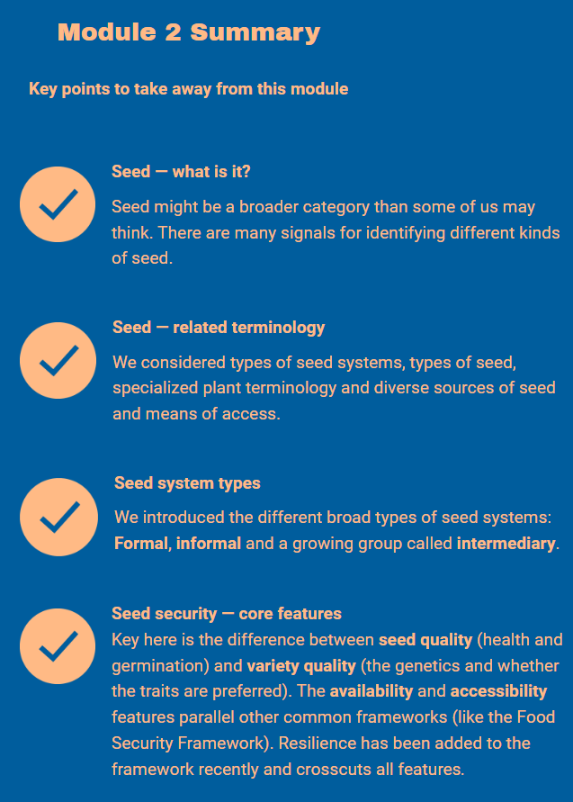  Change to:  Seed- what is it  Seed is a broader category than often recognized and there are many different signals for identifying it. Formal sector seed usually has packaging or may be dyed. Informal seed might be identified by how it is stored, or sorted or even its form (like maize left on cobs). So, seed can come in varied forms and diverse locales.  Seed- related terminology  Understanding seed-related terminology is fundamental to understanding seed systems. Key terminology to be familiar with include the various types of seed systems, types of seed, diverse sources of seed and means of access.  Seed system types  There are three broad types of seed systems: formal seed systems, informal seed systems, and intermediary seed systems. One type of seed system isn’t necessarily better than the other and all three can offer important benefits to farming populations.  Seed security -core features  There are four core features of seed security: seed availability (the physical quantity on offer, including where and when); seed accessibility (where seed can be acquired though cash, exchange or other); seed quality (its health and germination) and variety quality (the genetics and whether the traits are preferred. Resilience is sometimes added with it crosscutting all the central four features.
Module 3
SSSA- what is it | Text change  (add single word) | Current: We stress the word SYSTEM in SSSA. We are not calculating ‘seed needs’ (i.e we are not assuming that tons of seed will have to be distributed). Rather, the method aims to determine what range of actions can bolster seed systems and farming households, even if immediate aid is needed at all.  Change to  We stress the word SYSTEM in SSSA. We are not calculating ‘seed needs’ (i.e we are not assuming that tons of seed will have to be distributed). Rather, the method aims to determine what range of actions can bolster seed systems and farming households, and even if immediate aid is needed at all.
Dynamism in channels | Text change | Current text: Farmers may also shift channels to capture good opportunities — to get seed of new varieties or a novel crop all together.  Farmers are active managers. They carefully watch the weather, the markets and even their neighbors' fields to see what crops are performing and to think forward to future seasons. They then source seed accordingly.  Hence, the SSSA method looks at seed channels as a group — as a system — to get the whole picture. Weaknesses in some channels may affect only some crops, and sometimes weaknesses can be compensated for relatively easily.  Shift in use of the seed system channels can reflect farmers’ changing strategy, trying to adapt (and switch crops) or to adopt — something new.  Change to:  Farmers may also shift channels to capture good opportunities — to get seed of new varieties or a novel crop all together.  Hence, the SSSA method looks at seed channels as a group — as a system — to get the whole picture. Weaknesses in some channels may affect only some crops, and sometimes weaknesses can be compensated for relatively easily.  Shift in use of the seed system channels can reflect farmers’ changing strategy, trying to adapt (and switch crops) or to adopt — something new.
Fieldwork schedules |  | Change files to open as button. Also add links to website)
Data entry | Text adds | Current text: Data Entry  Data is entered in a specially designed Excel spreadsheet  within the data entry tab.  Change to: Data is entered in a specially designed Excel spreadsheet  within the data entry tab.  Increasingly, household data can also be collected on digital devices (not on paper forms). With digital data collection, the transfer to excel sheets is very quick!
Data check | CUT SECTION | 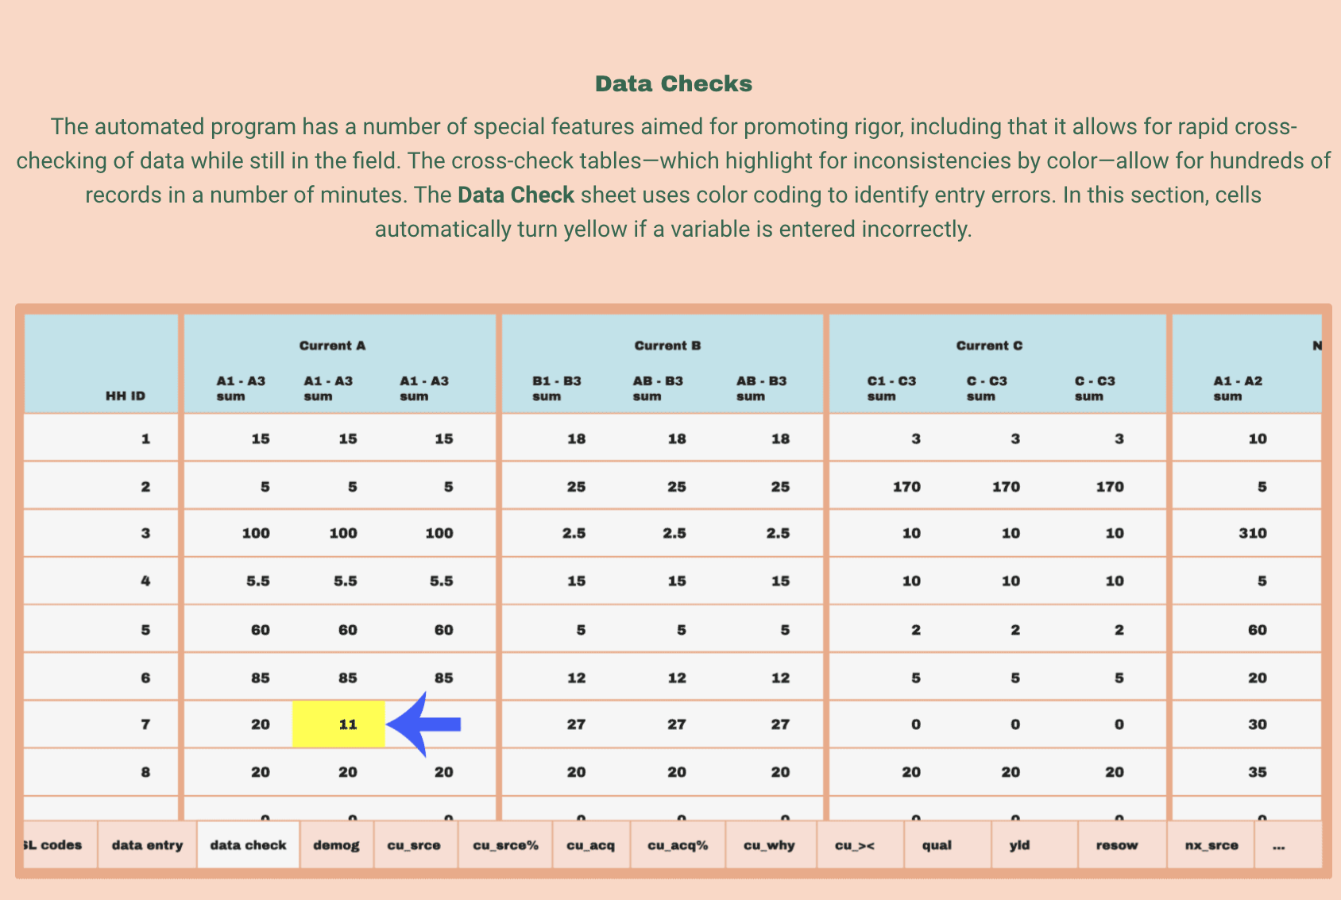
Data disaggregate results | Remove one of the images- the second | Remove/cut this image  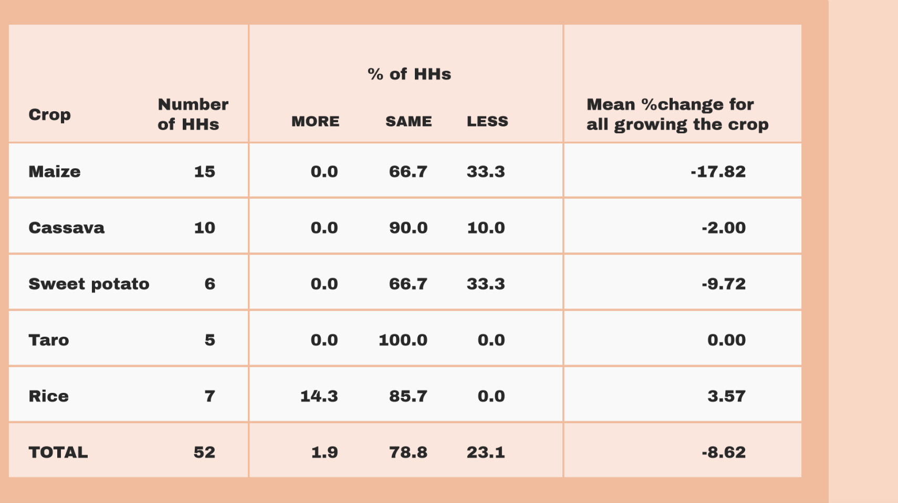
Module 4
Women’s focus group download | Change download to direct link on seedsystem | (see under header- individual household interview  https://seedsystem.org/assessments-and-e-learning-course/seed-system-security-assessment/focus-groups/
Process tip- community focus group. | Remove quotes | Current text  Prepare flipcharts before a meeting, theme by theme. Flipchart sheets can help a community ‘see the information being recorded’.  Change to:  Prepare flipcharts before a meeting, theme by theme. Flipchart sheets can help a community see the information being recorded.
Process tip (first one) | Text add | Current text: Click below to view example flipchart sheets.  Change to : Click below to view example flipchart sheets for use in community focus group
Crop priorities and use | Text change | Current: When with the community, make a quick list of all crops grown, then indicate how important they are for food or income. Use indicators shown as high (★ ★ ★  Change to: When, With the community…
Crop performance table | Text add | Put * (single start) in each cell that presently has none  Maize- middle column  Groundnut- middle and last column
Crop trends – follow up section | Text- combine and edit | Current text:  Note that there are other broad questions in this overview section of the community interview.  Simply, the challenge is to get the big crop picture before homing in on seed issues per se.  Change to:  Note that there are other broad questions in this overview section of the community interview. The challenge is to get the big crop picture before homing in on seed issues per se.  (combine and delete ‘Simply’)
Seed mapping | General drawing process | It is too slow. Can the actual drawing process be sped up
Seed mapping | Top and bottom parts of sheet | Draw the top and the bottom results on the same page. Not two pages
Seed mapping | Step 3 text. | Current text: Step 3  Apply the same method for the bottom section, looking back at how seed was then sourced. Discuss with the group.  Change to: Step 3  Apply the same method for the bottom section, looking back at how seed was then sourced--- 5 years ago. Discuss with the group.  Discuss and compare the top chart (current sources) with the bottom chart (5 years ago). Are there differences—and why
Seed mapping demo | Step 3 | Bottom of page.  Own stocks should link to crop and NOT to agrodealer
Group discussion notes | Text add | Current:  Group discussion notes:  • The Agrodealer network functioned well.  • Most maize used was hybrid and was purchased every season (maybe 90%).  •  Change to. (just add date header)  Group discussion notes:  2004- ‘5 years ago’  • The Agrodealer network functioned well.  • Most maize used was hybrid and was purchased every season (maybe 90%).
Group discussion notes | Spell out OPV | Current text  Group discussion notes:  • The Agrodealer network functioned well.  • Most maize used was hybrid and was purchased every season (maybe 90%).  • OPV use was small — but introduced by ICRISAT (an international research organization).  • Farmers did not like the OPVs and could buy fertilizer easily — so needed for hybrids  Change to  Group discussion notes:  • The Agrodealer network functioned well.  • Most maize used was hybrid and was purchased every season (maybe 90%).  • Open- pollinated Variety (OPV) use for maize was small — but introduced by ICRISAT (an international research organization).  • Farmers did not like the OPVs and could buy fertilizer easily — so needed for hybrids
Focus group summary | Tool link | Link directly to website  https://seedsystem.org/assessments-and-e-learning-course/seed-system-security-assessment/focus-groups/
Where they sourced their seed | General drawing process | It takes too long to fill in the table. Can the drawing process be made faster
Where they sourced their seed | New section  Results | (this comes after the table and before the process tip)  Results (partial) :  For this household, multiple sources are used to get maize seed, involving quite different means of access (saved, bought, gifted).
Data Overview | Text change (0ne word) | Current:  The overview table which emerges from these HH forms, …  Change to:  The aggregate table which emerges from these HH forms, gives a powerful overview of seed sourcing patterns across households.
Software | DELETE FULL SECTION | DELETE full section
Module 4  Question 3- answers | Text add | Current:  Teams have to learn whether is amount presents a stress at all.  Change to:  Teams have to learn whether this amount presents a stress at all. If so, maybe only a small set of farmers will need assistance.
Module 5
Introduction | Add to text | Current text:  The supply analysis of the SSSA particularly focuses on the varied market channels which might supply seed.  Change to  The supply analysis of the SSSA particularly focuses on the varied market channels which might supply seed. These market channels might provide seed in addition to the stocks that farmers might have saved themselves.
BIG questions | Modify text | Current text:  The SSSA markets assessments basically mirror the parameters of seed security: availability, access, and quality.  Change to:  The SSSA markets assessments basically mirror the parameters of seed security: availability, access, seed quality and variety quality.
Types of markets | Add text | Current text: Local Markets  (meaning also regional with focus  on ‘potential seed’)  Change to: Local Markets  (meaning also regional with focus  on ‘potential seed’ or local seed)
Choice of market channels | Text add  (0ne word) | Current  Here is a glimpse at the latest data summarizing farmer sources for seed.  Change to  Here is a glimpse at the latest data summarizing overall smallholder farmer sources for seed.
Seed from local markets | Text add | Current:  So, traders recognize that ‘potential seed’ might give a 25–50% premium of over stocks suitable for grain only.  Change to: So, traders recognize that ‘potential seed’ (right varieties and well-managed stocks) might give a 25–50% premium of over stocks suitable for grain only.
Tool for trader management of stocks |  | Current: The tool sketches the degree to which potential seed is managed in a particular locale and also which select traders anticipate this potential seed niche.  Change to: The tool sketches the degree to which potential seed is managed in a particular locale and also which select traders anticipate this potential seed (local seed) niche.
Larger traders | Two changes; add word, add comma | Current text  Lastly, a third potential seed market tool focuses on larger traders, those who manage supplies within and across regions.These traders can give salient insights on business trends, constraints and future possibilities.  This specialized larger trader tool queries about seed volumes, prices, and complementary inputs (like fertilizers and pesticides) and compares data for two seasons (or more).  How large is large? It depends on crop and locales. For example values like 200 mt to 400 mt have been noted in the field for single traders.  Change to:  Lastly, a third potential seed market tool focuses on larger traders, those who manage significant supplies within and across regions.These traders can give salient insights on business trends, constraints and future possibilities.  This specialized larger trader tool queries about seed volumes, prices, and complementary inputs (like fertilizers and pesticides) and compares data for two seasons (or more).  How large is large? It depends on crop and locales. For example, values like 200 mt to 400 mt have been noted in the field for single traders.
Larger trader results | Delete whole table + its text  (table before summary) | DELETE:  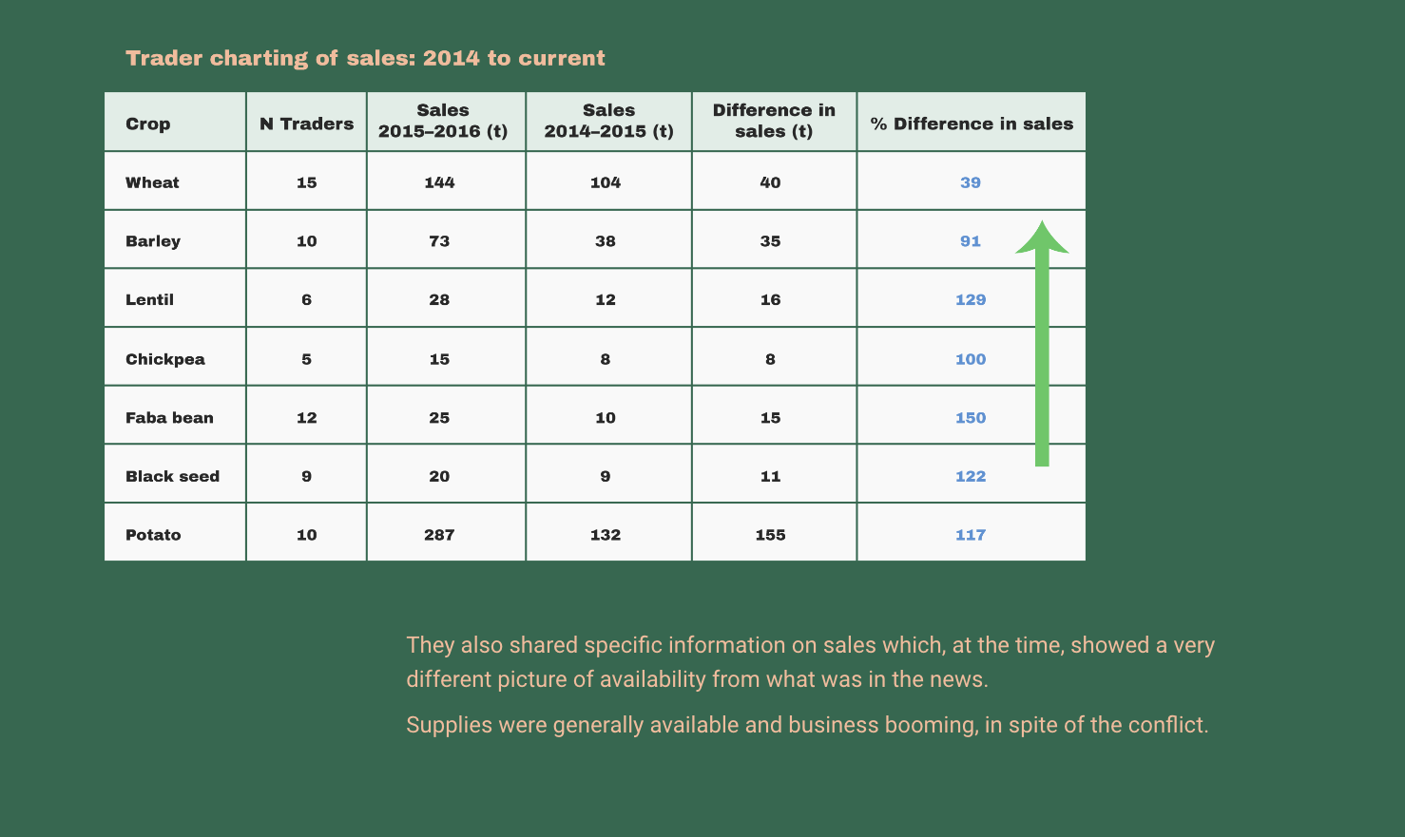
Summary- | Text add | Current: Overall, these potential seed market tools give a fast but highly realistic view of supply availability and price. They are solid enough to signal if there is a key disruption (and what kind) or if trends are within the range of normal. Traders do know clearly the ranges of variation — over space and time.  Change to:  Overall, these potential seed (local seed) market tools give a fast but highly realistic view of supply availability and price. They are solid enough to signal if there is a key disruption (and what kind) or if trends are within the range of normal. Traders do know clearly the ranges of variation — over space and time.
Agro-dealer supply | Combine sentences | Current:  The SSSA tool used to learn from agro-dealers very much parallels the large trader tool.  It looks at volumes and prices, and can offer great insight on the general business operating environment.  Change to: (just combine the two sentences)  The SSSA tool used to learn from agro-dealers very much parallels the large trader tool. It looks at volumes and prices, and can offer great insight on the general business operating environment.
Agro dealer quantitative data Tanzania | Change in text formatting and adding some text | Current:  Two examples, both from southern Tanzania, suggest the kind of data collected, which gives a quick snapshot into agro-business as it would affect smallholders. It was a stable period, business volumes were on the rise and prices within a normal range of variation.  Key again, is not the exact figures, but to see if there are marked signals of stress.  If so, for which crops, which inputs, and why? (causes, trends).  Quantitative data is always complemented by extensive discussion.  Change to:  Two examples, both from southern Tanzania, suggest the kind of data collected, which gives a quick snapshot into agro-business as it would affect smallholders.  The tables below show that it was a relatively stable period. Business volumes were on the rise. Also prices were relatively stable. (THIS SECTION NOT BOLD)  Key again, is not the exact figures, but to see if there are marked signals of stress. If so, for which crops, which inputs, and why? (causes, trends).  Quantitative data is always complemented by extensive discussion. (COMBINE THE TWO SENTENCES)
Process tip | Text edit down | (CHANGE TO: Just eliminate strikethroughs)  When interviewing both traders and agro-dealers, bear in mind that they may have vested interests and are always keen to make a sale. Relief workers and other aid personnel involved in alleviating a crisis are among the most sought-after buyers because volumes are high and payment is usually rapid. Thus, interviews with agro-dealers and traders (i.e. potential suppliers) to obtain objective information must be divorced from any contact or action linked to seed purchases.  Don’t even think about getting reliable market intelligence at the same time you’re putting in a seed order! Agro-dealers and traders ‘smelling’ potential business will usually supply information that suggests seed is available, that “it can be found”.  Agrodealers and traders will also probably be more comfortable revealing details of their business if they have an explicit guarantee that the information will remain confidential. As in any profession that relies on interview techniques to obtain potentially sensitive information, those conducting the SSSA should respect ethical guidelines regarding confidentiality, privacy, and consent.
Quality of seed market assessments | Text edit down | Change to: (just eliminate strikethrough)  Perhaps unexpectedly, across SSSAs to-date, farmers’ seem fairly content with seed quality from all sources, with seed being judged poor in less than 4% of cases overall. (However, farmers’ may variously assess this).
Farmers’ perception of seed quality table | Total needs to be change to Average | Current  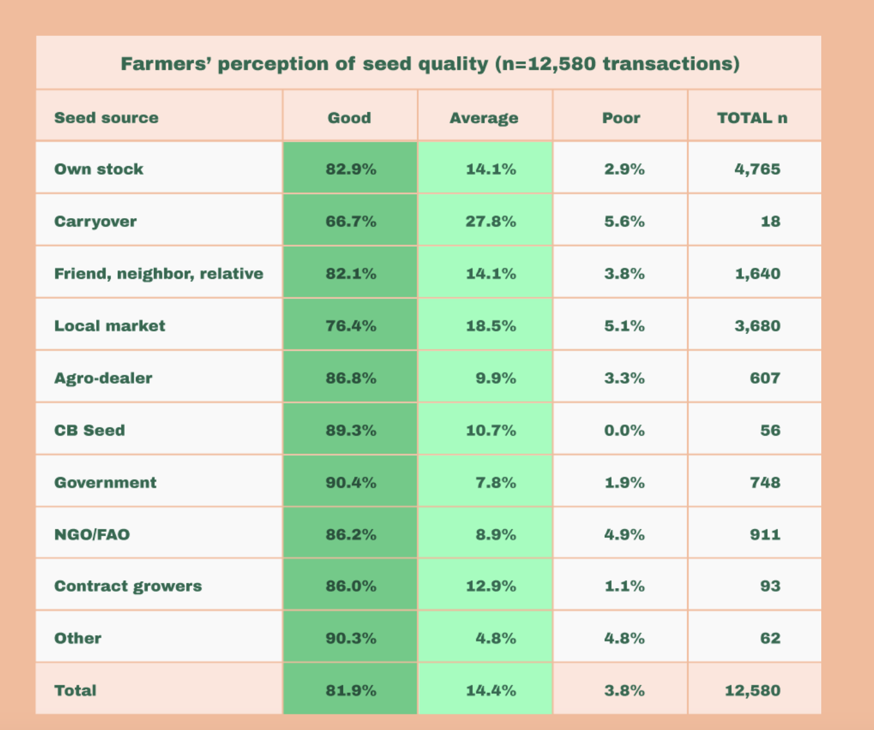  Change  Last row should be Average. Not Total
END TEST
Eliminate question 6 |  | Eliminate all together question 6
Change wild card question |  | Put current question 7 as wildcard
Current question 7  to become wildcard question) | Change text | Current .Markets key to assess to understanding smallholder seed security...  Change to: Markets key to assess for understanding smallholders’ seed security...
Module 6 | Linking evidence to responses
Title slide- before launch | Delete single word | Current : This module looks now at some…  :  Change to. This module looks now at some…
Process tip | Text to be added at beginning | Current :  Process Tip  Are relief organizations and development workers sufficiently positioned to make quality interventions feasible?  Is there enough time to analyze, design, and implement before the next cropping season?  Is the needed expertise, both technical and social, available to ensure that advice is sound and that planned actions can benefit stressed populations?  Change to (just add highlighted yellow)  Process Tip  ADD: Some basic questions need to consider prior to moving forward on any intervention:  Are relief organizations and development workers sufficiently positioned to make quality interventions feasible?  Is there enough time to analyze, design, and implement before the next cropping season?  Is the needed expertise, both technical and social, available to ensure that advice is sound and that planned actions can benefit stressed populations?
Seven common problems identified | Text change at end of introduction | Current text: For each, the constraint is introduced and a set of possible responses listed. One then explores which are appropriate — or not.  Change to: For each, the constraint is introduced and a set of possible responses listed. One then Explores which are appropriate — or not.
Acute problem 1- I need more seed for my farm, but cannot access it.. | Change single word | Answer: Cash grants (just change one wrd)  Current answer: With cash, farmers can buy anything they want- which is a real strength. However, they may not necessarily buy seed at all, if they have more pressing priorities. Careful analysis of the context and beneficiary targeting can increase the chances of cash being used for the intended purpose.  Change to: With cash, farmers can buy anything they want- which is a real strength. However, they farmers may not necessarily buy seed at all, if they have more pressing priorities. Careful analysis of the context and beneficiary targeting can increase the chances of cash being used for the intended purpose.  That said, in the end, what matters is that the cash grant contributes to beneficiary wellbeing.
Acute Problem 3  I urgently | More info section  (add letter) | Current; 4. Follow-up has to be schedule in intervention. Did the innovations work — or not?  Change to: 4. Follow-up has to be scheduled in intervention. Did the innovations work — or not?
Chronic stress issue 6  We can’t get these varieties the radio keeps talk about | Single word change | Current:  6. Particularly in chronic stress areas, many farmers lack access to crop or variety innovations that can strengthen system performance. The constraint requires an emergency response with a view to longer-term issues – from the start (i.e. how to link relief to development).  Change to: Particularly in chronic stress areas, many farmers lack access to crop or variety innovations that can strengthen system performance. The constraint requires an emergency response a shorter-term response with a view to longer-term issues – from the start (i.e. how to link relief to development).
Chronic issue 7  I can’t find information on these drought.. | Delete single word | Current:  7. Important crop and variety innovations may be available for communities but farmers may not have information on them. Also, demand can't be created  Change to: … may not have information on them. Also, Demand can't be created
Seed system goals | Intro text --shorten | Current:  Finally in the last overview section on technical responses, we focus on goals. What are your seed system goals? What is your seed security vision? Seed security can be linked to a diverse set of goals.  There are four main goals on which to reflect. Systems aimed to increase food production (more calories? Staggered production?), seed systems to bolster nutrition, seed systems designed to ensure greater system resilience (dealing with good/bad seasons and climate-related stresses more generally), and seed systems geared to help farmers make more money, income (perhaps linked to value chains or other agro-enterprise).  These seed systems all have critical elements in common but they also have their own distinct characteristics. We need to understand and actively plan for these characteristics if we are to achieve our specific goals. Goals shape the technical content of the seed security response very directly.  Change to:  Finally in the last overview section on technical responses, we focus on goals. What are your overall seed system goals? What is your seed security vision? Seed security can be linked to a diverse set of goals. Overall goals shape the technical response.  There are four main goals on which to reflect. Systems aimed to increase food production (for instance, aim for more ; or calories staggered production), seed systems to bolster nutrition, seed systems designed to ensure greater system resilience (for instance, dealing with good/bad seasons and climate-related stresses more generally), and seed systems geared to help farmers make more money, income (perhaps linked to value chains or other agro-enterprise).  These seed systems all have critical elements in common but they also have their own distinct characteristics. We need to understand and actively plan for these characteristics if we are to achieve our specific goals. Goals shape the technical content of the seed security response very directly.
Seed System goals, image | Change text on image and add title | Current:  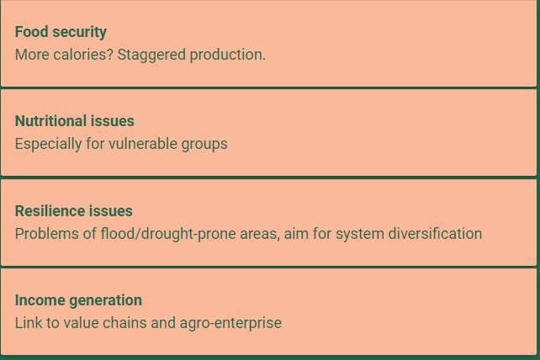  Change to:  - Add title to image. Possible seed system goals  - Remove all subtext:  - More calories, staggered production  - Especially for vulnerable groups  - Problems of flood/drought-prone areas  - Linked to…value chains  - Change these row headers  Nutritional issues. To Nutrition  Resilience issues to Resilience
Seed System goals | Intro bolded section.  Take away bold and shorten  Add click tab instructions | Current text:  You might think that all these can be achieved at once — it will just happen if we do our job right. In reality, there are central choices to make according to your seed system goal.  To illustrate this key point, let's start with seed systems aimed at food production, as much of the seed system work uses this model as the base (and then adds more specialized features).  And let’s just consider two central planning features: 1) what should shape the crop/variety choice? and then 2) what might be core elements in the awareness-raising/demand creation strategy?  Here is the practical example of these planning features — when food production is the driving seed system goal.  Change to:  You might think that all these can be achieved at once — it will just happen if we do our job right. In reality, there are central choices to make according to your seed system goal.  To illustrate this key point, let's start with seed systems aimed at food production, as much of the seed system work uses this model as the base (and then adds more specialized features). And let’s just consider two central planning features: 1) what should shape the crop/variety choice? and then 2) what might be core elements in the awareness-raising/demand creation strategy?  Here is the practical example of these planning features — when food production is the driving seed system goal.  ADD: Click each goal tab to explore its features
Seed system goals | Shorten text  Remove bold | Current text:  Now let’s look at other goals and some key planning features. Again, seed system for food production serves as the base. Features for other goals need to be added to this classic base.  Explore the goals below and take note of the example features across each of the columns.  Click each goal tab to explore their features  Change to:  Now let’s look at other goals all the goals together and some key planning features.. Again, seed system for food production serves as the base. Features for other goals need to be added to this classic base.  Explore the goals below and take note of the example distinct features across each of the columns. Click each goal tab to explore their features
Seed system goal text | Remove bold, add, Combine some sentences | Current: To reach overall seed system goals, many active decisions have to be made beyond the general choice of the technical response, like DSD, or seed fairs.  One has to make precise decisions on: which crops, which varieties, which information strategies…  One has to be clear about the overall aim of the response, that is, the overall goal.  Change to:  To reach overall seed system goals, many active decisions have to be made beyond the general choice of the technical response, like DSD, or seed fairs.  One has to make precise decisions on: which crops, which varieties, which information strategies…  One has to be clear about the overall aim of the response, that is, the overall goal.
Drag and drop exercise | MOVE to new section- test your knowledge
ADD new section TEST YOUR KNOWLEDGE | TEST YOUR KNOWEDLGE SECTION- new | STRUCTURE  - 2 True or false questions  - The Drag and drop (below) structured as three questions  (features for nutrition – drag and drop  Features for resilience- drag and drop  Features for income- drag and drop)  - ) 1 wild card question
New True and False Questions  2 questions | Test your knowledge  New Questions | Question 1  If the seed security problem is linked to farmers’ lacking means of access (for example, having no money), the best response is to give free seed (direct seed distribution-DSD)  TRUE- incorrect  FALSE- DSD does bring seed to farmers, but addresses mainly a constraint of availability, not access.  While it might lessen stress in the short-term, DSD doesn’t strengthen existing channels (and can undermine markets). If possible, one might better implement voucher or cash approaches, which can be tied to farmers’ accessing seed from ongoing channels.  Question 2 (true or false)  Addressing seed security problems linked to seed quality (for example, poor seed health or low germination rates) always requires longer-term approaches.  TRUE. To address seed health issues, there are no quick fixes. Also, one might best take a multi-pronged approach and work on improving seed health of a) farmers’ own seed stocks; b) seed in local markets and c) seed on offer from formal companies/agro-dealers.  FALSE- incorrect
Module 6 exercise drag and drop  This will become part of the Test your knowledge section, a new section | Drag and drop- will become 3 scored questions in test your knowledge | Current format. (all three drag and drops are together)  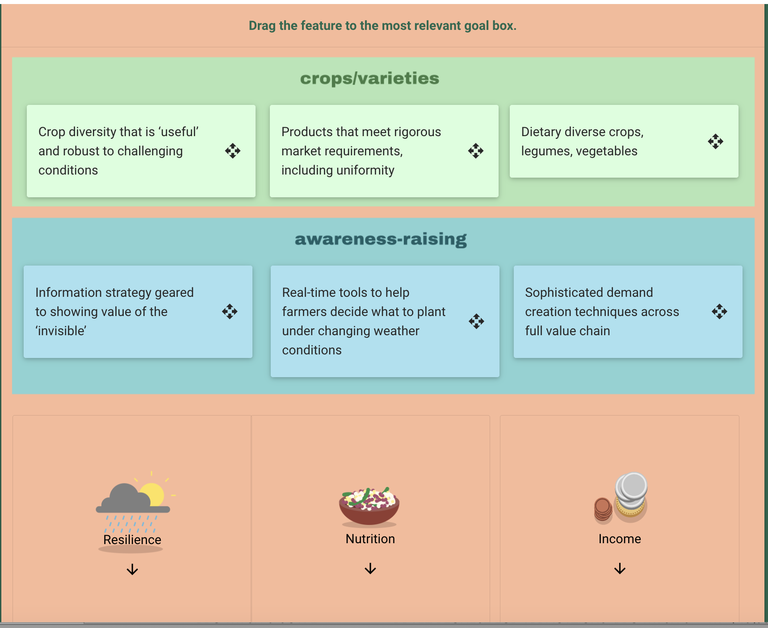  Change to. Explore drag and drop to goals one by one. Resilience (drag crop choice and awareness raising—then score; nutrition- drag crop and awareness raising, then score; income- drag crop choice and awareness raising then score  Maybe need to flip diagram. So goals are vertical and on right
Module 6- add wild card question  ADDDED  To test your knowledge | WILD CARD question- module 6 | WILD CARD QUESTION  Many factors shape choice of technical responses, beyond the seed security problem identified.  Check which of the following factors are important for guiding choice action on the ground (multiple selections are possible) (designer - draw boxes with checks to be added)  - Institutional preference- Organizations may have a favored approach  - Differing expertise – Organizations may lack technical expertise to weigh diverse options  - Funding levels- the amount of money available to organizations might determine what can be technically implemented  - Time Commitments- Organizations may have mandates to work pre-scheduled time periods, for example : only 1 season; 2 seasons (short-term); or more seasons (medium or longer- term)  - All of the above  - None of the above  ANSWER:  Correct- 5 –All of the above  Partially incorrect if any are chosen  Incorrect- 6 if none of the above is chosen
Module 7
Scenarios | Text modification | Current”  Here are three diverse disaster and response scenarios to explore. Each case selected is based on a real set of events and presents some evidence from actual SSSAs. In some cases, we have taken liberty with precise facts to help emphasize key points.  Change to:  Here are three diverse disaster and response scenarios to explore. Each case selected is based on a real set of events and presents some evidence from actual SSSAs. In some cases, we have taken liberty with precise facts simplified the evidence to help emphasize key points.
Haiti scenario
Introduction- where map is | Text modification | Current : Haiti is often plagued by acute disasters, often hurricanes. The earthquake was unusual. Overall, even in normal periods, farmers have had little access to agricultural innovations (including new varieties or quality seed) with the rice industry being a notable exception. Government services are irregular and infrastructure poorly developed throughout most of the country. Investment is also partly limited for reasons of accountability.  Change to:  Haiti is often plagued by acute disasters, often hurricanes. The earthquake of 2010 was unusual. Overall, even in normal periods, farmers have had little access to agricultural innovations (including new varieties or quality seed) with the rice industry being a notable exception. Government services are also irregular; and infrastructure poorly developed throughout most of the country; and investment is also partly limited for reasons of accountability.
Haiti- Evidence from SSSA  TITLE | Text (number) change  (2011 to 2010) | Current:  Evidence from SSSA  What did the SSSA find in 2011?  Change to:  Evidence from SSSA  What did the SSSA find in 2010?
Haiti- evidence from SSSA (picture diagram)  Tab : Seed Channels | Text correction and reduction | Current:  Seed channels are static (perhaps for all crops but rice). In the SSSA, only 1.5% of seed came from commercial channels as agro-dealers barley exist.There are decentralized seed producers set up (mainly by the UN) who produce minimal quantities but with no clear marketing strategy: the artisanal groups seem to produce for the Aid Buyers. Farmers have very little access to variety innovation. Only 14% had obtained a new variety in ‘last five years--- very low !--- and basically from seed aid. There was little ago-processing anywhere across countrywide SSSA sites.  Change to:  Seed channels are static (perhaps for all crops but rice). In the SSSA, only 1.5% of seed came from commercial channels as agro-dealers barley exist.There are decentralized seed producers set up (mainly by the UN) who produce minimal quantities but with no clear marketing strategy: the artisanal groups seem to produce for the aid buyers. Farmers have very little access to variety innovation. Only 14% had obtained a new variety in ‘last five years--- very low !--- and basically from seed aid. There was little agRo-processing anywhere across countrywide in SSSA sites.
Haiti- evidence from SSSA  Tab . Seed use | Single period missing at end | Current:  Across all sites, the emergency aid seed provided (immediately after the quake) contributed but 4% of the total seed sown and in the epicenter, Leogane, only 3.4% of seed sown. Simply, farmers used their normal seed channels (despite the humanitarian give-aways)  Change to:  ….. (despite the humanitarian give-aways).
Haiti- evidence from SSSA  Tab. Chronic stress | Text correction (esp. commas) | Current  Haitian farmers routinely buy a huge amount of the seed they sow, from local markets season after season. 75% of seed sown (the highest rate recorded worldwide). This is linked to basic poverty. Selling at harvest to meet immediate needs. They also routinely eat their seed — not as a sign of particular stress — but because they can easily get needed varieties from local sellers who prefer to shift storage risk to traders.  Change to  Haitian farmers routinely buy a huge amountS of the seed they sow, from local markets, season after season. 75% of seed sown (the highest rate recorded worldwide). This is linked to basic poverty as harvests are sold immediately to meet basic needs. They Farmers also routinely eat their seed — not as a sign of particular stress — but because they can easily get needed varieties from the local market and prefer to shift the storage risk to traders.
Haiti- evidence from SSSA  Tab. Agriculture | Text add | Current:  In terms of agriculture overall, there was an insignificant change in area cultivated, but labor access did decrease for about ¼ households: people were on the move.  Change to  In terms of agriculture overall, there was an insignificant change in area cultivated due to the earthquake, but labor access did decrease for about ¼ households: people were on the move.
Haiti  Slide: seed security responses | Title  (add single word) | Current  In such a context, what might be useful in terms of seed security (or was deemed most useful in the short-term?)  Change to  In such a context, what might be useful in terms of seed security response (or was deemed most useful in the short-term?)
Haiti-  Slide medium term responses | Text- add single word | Current  A few of the many programs that seem essential:  • Professionalize the decentralized seed producer groups that exist: strengthen their business and marketing skills.  • Find ways to help farmers get exposed and buy new, performing varieties — maybe small pack sale in routine rural shops.  • Engage Madam Sara’s and other routine seed/grain sellers to recognize and maintain and sell higher quality of varieties and better quality of seed/grain (even if not certified — but which can he used for sowing).  Change to: (add single word. to)  …  Find ways to help farmers get exposed to and buy new, performing varieties — maybe small pack sale in routine rural shops.  …
Malawi Scenario
Southern Malawi: Evidence from SSSA (picture diagram)  Tab: seed saved | Text change. | Current:  The season was a good one: farmers sowed 14% more than normal and yields across were generally good. Maize was the exception, which farmers said performed poorly over years (8 out of 9 fails for three sites).  Change to:  The season was a good one: farmers sowed 14% more than normal and yields across crops were generally good. Maize was the exception, which farmers said performed poorly over seasons years (8 out of 9 fails for three sites).
Southern Malawi- short-term seed security responses- title | Text change | Current  Short-term  Seed Security Responses  In such context as previously described, what might be the most useful short-term response?  Change to:  Short-term  Seed Security Responses  In such context as previously described, what might be the most useful short-term responseS?  (designer- note that this formatting is not the same as in the Haiti case. Might be best to standardize across cases
Southern Malawi- short-term seed security responses- Item C | Text change/add | Current (before card is flipped to answer)  C.  Vouchers tied to fairs or DiNERs  Change to:  C.  Vouchers tied to fairs or DiNERs—for diversity of crops
Southern Malawi- short-term seed security responses- item D | Text change/add | Current (before card is flipped)  D.  Vouchers tied to Fairs or DiNERs?  Change to:  D.  Vouchers tied to Fairs or DiNERs—specifically for cassava?
Zimbabwe Scenario
Context slide | Text- change commas to parentheses- for consistency | Current  The four sites assessed in Zimbabwe were diverse, ranging from a good potential maize hybrid-growing area, Murehwa, to  Change to  The four sites assessed in Zimbabwe were diverse, ranging from a good potential maize hybrid-growing area (Murehwa) to
Zimbabwe- Evidence from SSSA (picture diagram)  Tab: Money concerns | Text change  (clarification.  Also sweetpotato is one word | Current:  But, prices were hyper inflated. Normally: 1 bag fertilizer = 3 buckets Sweet potato ($2 x 3 = $6). In the 2009 season: 1 bag = 15 buckets — some 5x the routine price ($30).  Change to:  But, prices were hyper inflated. Normally: 1 bag fertilizer = 3 buckets sweet potato ($2 x 3 = $6). In the 2009 season: 1 bag of fertilizer = 15 buckets — some 5x the routine price ($30).
Zimbabwe-  Short term seed security responses | text | Current:  In such context as previously described, what might be the most useful short-term response?  Change to:  In such a, what might be the most useful short-term responseS
Zimbabwe- medium term | Text  Delete comma | Current  What might be useful: focus on the medium term, in Zimbabwe (as many places elsewhere).  Change to; (just delete comma)  What might be useful: focus on the medium term in Zimbabwe (as many places elsewhere).
SWING and MISS | DELETE WHOLE SECTION | Delete all five exercises
Module 7 summary | Currently there are three points. Need to only be two. | Current ;  Module 7 Summary  This module explored actual disaster and stress scenarios where seed security issues were important.  Haiti (earthquake, drought, but lack of innovation for years) was different from Zimbabwe (currency breakdown and drought aftermath) and from Malawi ( which was maize crazy with little crop diversification and high rates of chronic malnutrition).  Each context demanded seed security responses which were both short-term and longer-term. Acute stress is nearly always the top layer to a series of longer-term chronic stresses  The module then ended with modesty — that we all can make real mistakes in response. One important point is to learn. Really evaluate and reflect on what has been implemented. What went well? What can be done better if there is a next time.  Change to:  Module 7 Summary  This module explored actual disaster and stress scenarios where seed security issues were important.  Haiti (earthquake, drought, but lack of innovation for years) was different from Zimbabwe (currency breakdown and drought aftermath) and from Malawi ( which was maize crazy with little crop diversification and high rates of chronic malnutrition).  Each context demanded seed security responses which were both short-term and longer-term. Acute stress is nearly always the top layer to a series of longer-term chronic stresses. (add period)  The module then ended with modesty — that we all can make real mistakes in response. One important point is to learn. Really evaluate and reflect on what has been implemented. What went well? What can be done better if there is a next time.
Module 8
Opening image with all the people | Text edit | Current  .. Much has been covered, so let's now summarize key lessons learned in each module, then reflect on the big challenges for moving forward.  Change to  Much has been covered, so Let's now summarize key lessons learned in each module, then reflect on the big challenges for moving forward.
Module 1- SSSA introduction  As the rate of disaster rises section | Change in current dates on chart | These changes have to mirror the changes in this timeline updated in module 1
Module 2  Seed system basics | Updating figures  Seed as money business | Current  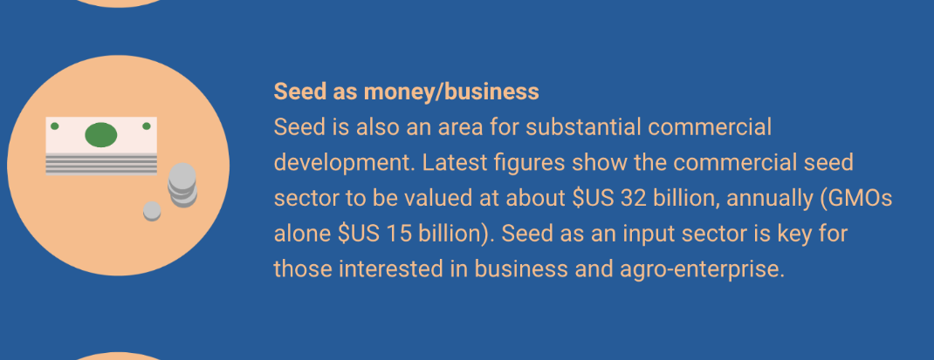  Change to: (As in Module 1. 61 billion. 46% GMOs)
Module 2  Marron box : seed | Change two words-- add | Current:  Seed can be sourced from diverse places, like farmers’ own stocks, specialized agro-dealer stores, community-based producer groups, and even local markets (with the latter selected out as ‘potential seed’).  Change to  Seed can be sourced from diverse places, like farmers’ own stocks, specialized agro-dealer stores, community-based producer groups, and even local markets (with the latter selected out as ‘potential seed’ or local seed).
Module 2  Seed security box | Change features in the box to match the revised box module 2 | Current  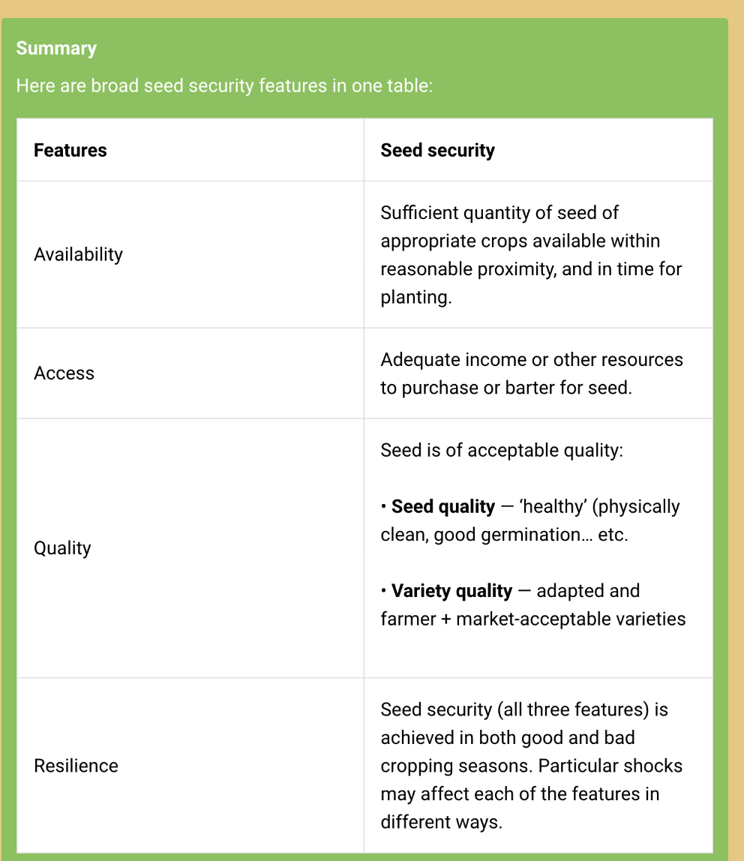  Change to (check module 2, Copy same format)
Module 3  The data analysis text | Text edit- add | Current  A unique feature of the SSSA is a software program whereby data is entered in excel (simple!) and formatted tables and graphs emerge seconds later... These immediate results help guide team’s practical decision-making in the field and in real-time.  Change :  A unique feature of the SSSA is a software program whereby data is entered in excel or transferred from tablet (simple!) and formatted tables and graphs emerge seconds later... These immediate results help guide team’s practical decision-making in the field and in real-time.
Module 4  Section on reasons for sowing less seed | Text change in marron box | Current: Very often, SSSAs show that seed-related factors (and especially supposed lack available seed) are not the drivers of household seed use trends. Rather other non-seed factors like labor or land access, or changing market opportunities prove crucial for understanding what and how much farmers sow. So always asking ‘why a household does X’ is key for interpreting real seed security needs.  Change to:  Very often, SSSAs show that seed-related factors (and especially supposed lack of available seed) are not the drivers of household seed use trends. Rather other non-seed factors like labor or land access, or changing market opportunities prove crucial for understanding what and how much farmers sow. So always asking ‘why a household does X’ (sow more, less, or the same) is key for interpreting real seed security needs.
Module 4  Marron box on Money | Text change- spacing | Current: Money is probably the most frequent constraint to a household’s meeting seed security needs. …Hence the SSSA  (add more spaces before Hence)
Module 5- yellow box (right) for local | Text change, add words | Current: Tools here help describe the degree of seed management in local markets-as well as ‘potential seed’ availability.  Change to:  Tools here help describe the degree of seed management in local markets-as well as ‘potential seed’ or local seed availability.
Module 6 | Marron box- word correction | Current :  SSSAs need to be framed by some basic decisions on scope — before they before into specific technical choices shaping response.  Change to:  SSSAs need to be framed by some basic decisions on scope — before they before delve into specific technical choices shaping response.
Module 6 | Marron box (on right) Text change | Current: And as an accompanying process to the precise technical discussions — to address specific constraints — seed security responses need to be filtered through the lens of the tied to the desired overall seed system goal. There are at least 4 possible overarching goals.  The precise technical response will be shaped by goal. e.g. seed systems designed for income generation may differ from those aiming for better nutrition.  Change to:  And as an accompanying process to the precise technical discussions — to address specific constraints — seed security responses need to be filtered through the lens of the be tied to the desired overall seed system goal. There are at least 4 possible overarching goals. The precise technical response will be shaped by goal. e.g. For example, seed systems designed for income generation may have technical features different from those aiming for better nutrition.
Module 7 | Delete full section | CUT ALL THIS (linked to deleted section swing and a miss)  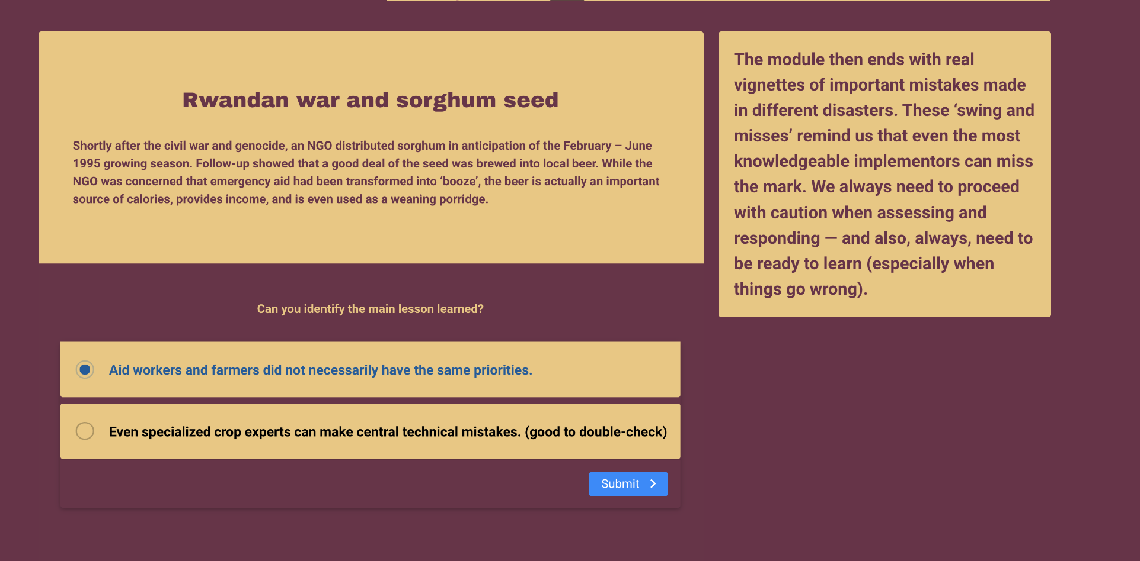
Statement before  (Yellow band) | Text change  Words and  (grammar) | Current:  This course has shared the framework, process and specific tools for conducting a Seed System Security Assessment (SSSA) and for linking the problems identified to a tailored set of seed security responses.  There is a clear, repeatable, and fast method – to get the needed evidence, and to make informed, smarter decisions as to which seed security-linked responses might be more effective.  Change to  This course has shared the framework, process and specific tools for conducting a Seed System Security Assessment (SSSA) and for linking the problems identified to a tailored set of seed security responses.  There is a clear, repeatable, and fast method to get the evidence needed so as to make more informed, smarter decisions on seed security response.
Summary | Text editing | Current:  We hope this course has been grounded and very practical — but also encouraged you to think more profoundly about seed systems and all the variations that farmers use.  You should now have a much better understanding of seed security, its features, varied problems farmers’ encounter and options for solving them.  There is no single ‘best bet’. There are many ‘better bets’ in gathering the evidence and deciding the more promising response options.  As donors and interveners, let's be flexible, strategic and willing to seek the best possible approaches according to the stresses (and opportunities) encountered.  Change to  We hope this course has been grounded and very proved to be practical for you and also encouraged more profound thinking about the multiple seed systems and all the variations that smallholder farmers use.  You should now have a much better understanding of seed security, its features, the varied problems farmers’ encounter and options for solving them.  There is no single ‘best bet’. There are many ‘better bets’ in gathering the evidence and deciding the more promising response options.  As donors and interveners, let's be flexible, strategic, and willing to seek the best possible shorter- and longer-term responses according to the stresses (and opportunities) encountered.
NEW section (after the course evaluation  Your score  And then certification of completion if score is 75% or more |  | [ not sure how to design this. Welcome designer thoughts on course section  Something like  “So how did you score on the course.” (The have score pop up)  (and if 75% or more  Congratulations: you have earned a certificate of completion- (then show certificate below for printing. Have them type in their name)  (if less than 75%). You made real progress (!!) but your understanding of seed security and its assessment still needs some improvement. Feel free to take the course again.

