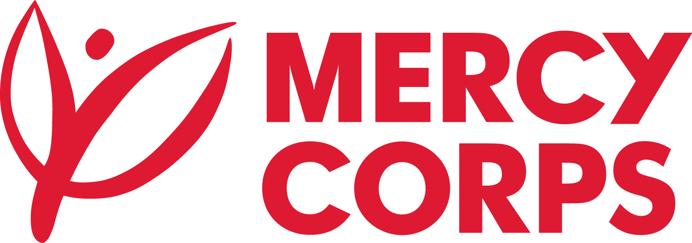
Date: December 2023
Reference No.: ET01/RIPA-N-CM3/Adadle/23

Tender notice (Re-invitation)
Mercy Corps is a non-religious, non-profit and non-governmental international humanitarian organization.

Mercy Corps is seeking qualified contractors: PREQUALIFICATION OF WATER WORKS CONTRACTORS FOR WATER SUPPLY WORKS IN ADADLE TOWN, SOMALI REGION, ETHIOPIA

If you are interested in submitting a technical offer, you should collect Request for Prequalification and submit it according to the guidelines below.
- Request for Prequalification of WATER WORKS FOR WATER SUPPLY WORKS IN ADADLE TOWN, SOMALI REGION can be picked up from Mercy Corps Addis Ababa office Yeka Sub-City, Kebele 08, House No. 377; Hayahulet, Tel. 011-1-110777
OR

- Bidders can send email to et-tender-questions@mercycorps.org and Request for PREQUALIFICATION Document.
Technical offer must be submitted to Mercy Corps Ethiopia Addis Ababa Office from December
25th, 2023, 8:00Am till 5th January 2024 5:00 PM in one of the below methods.
- Email completed technical offer to et-tender-questions@mercycorps.org with the Tender Reference number in the email subject line.

OR

- Return the completed technical offer in person and put in the Tender Box placed at Mercy Corps Addis Ababa office Yeka Sub-City, Kebele 08, House No. 377; Hayahulet. The Tender Reference number should be written on the envelope.

