Program/ Title | Integrating and Strengthening TransformativE Development and Employment for refugee Communities (InStede)
Program Location(s) | Xanadu; entire country; landlocked of approximately 25,000 square kilometers bordering 5 other countries
Duration | Work should begin sometime between February-April 2024 which is the 3-5 months prior to the end of the program. Final report must be submitted by June 30th, 2024

Background

InStede is implemented in Xanadu - a landlocked country that borders five other countries with administrative boundaries of four provinces and several counties within each province, followed by districts, and villages (rural) or neighborhoods (urban). There is civil conflict within Xanadu. There is civil conflict within two of its bordering countries. Although there is presently no conflict between Xanadu and its neighboring countries, there has been as recently as 7 years ago and the threat of that erupting is still present. The country faces a multitude of challenges resulting from the combined effect of prolonged conflict and economic shocks which have resulted in displacements, loss of livelihoods, loss of property and assets, destruction of infrastructure and dysfunctional markets among others. These shocks have also been seen to increase inter-communal tensions as there is increased pressure exerted on available limited resources. In response to some of these shocks, households have been forced to resort to negative coping mechanisms which continue to undermine both their immediate and long-term economic opportunities. There are four languages spoken in Xanadu; these are Tehuelche (northern province), Mandan (Eastern), Ngasa (southern) and Gugu Thaypan (Western). Only the Tehuelche are considered a minority accounting for only 11% of the Xanadu population whereas the others are more or less equally represented. All four languages are official languages and are used for teaching in primary and schools. English is taught as a second language in secondary school and is the language used in higher education.

1) Program to be Evaluated
This five-year program started on August 1st, 2019 and will end in July 31st 2024. Mercy Corps works with UNHCR, UNICEF, Texas Friends of Refugees Foundation and the Development Agency of Liechtenstein. InStede work with refugees in six refugee camps and also with refugees and IDPs in four urban settings. The camps and urban settings are distributed throughout the country; they are accessible all year round although some are by unpaved roads.

The program’s result framework is:
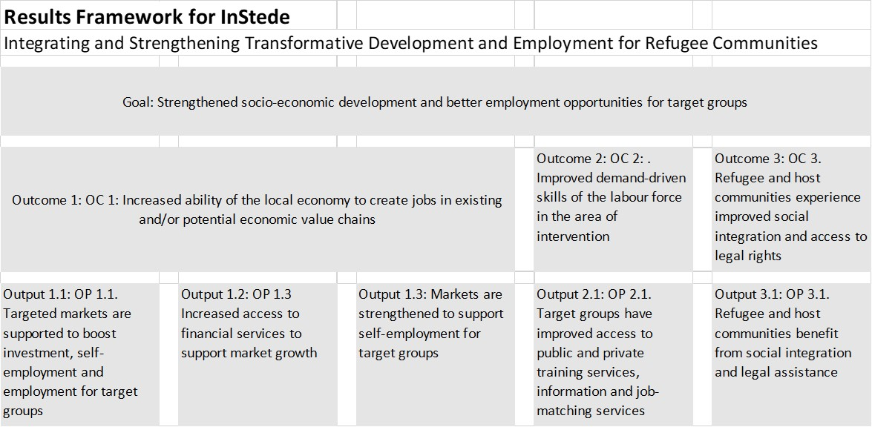

The key interventions are:
Title and description of InStede’s key interventions
1 Small Business Ideas Competition
2 Financial Inclusion (Expansion of MFIs, and establishment of VSLAs, and support to financial service providers)
3 Skill Development Intervention (Technical) and transferable soft skills
4 Strength Livestock Market System (goat fattening, Feedlot, and meat markets)
5 Improve Agriculture Production (Agricultural mechanization, Wheat farming, agriculture Input supply)
6 Waste Management and Recycling
7 Development of One-Stop-Center
8 Supply of hay/forage and veterinary drugs to drought affected households
9 Integration between host and refugee communities
10 Legal aid services

2) Final Evaluation Purpose and Objectives

The purpose of this final evaluation is make evidence-based value statements about the program’s performance that are anchored to the program’s (i) approved indicators and performance targets and (b) implementation of its work plans (i.e., delivery of its’ intervention package) accounting for factors that could have influenced (positively or negatively) the intervention delivery and/or achieving its intended outcomes.
The Specific objectives of the final evaluation are to:
2.1 collect the endline data for the following indicators using: (i) a random sample of the direct participants for Goal a and Outcome 2a, (ii) a random sample of all business supported by InStede over the life of the program for Outcome 1d, and (iii) a purposive sample of all Cooperatives supported by InStede over the life of the program for Outcome 2a. These data are used to complete the IPTT
InStede indicators obtained through the baseline and endline surveys
Goal a: positive 'net attributable income change
Outcome 1d: % of businesses who see a positive change in their business performance
Outcome 1e: % of cooperatives functional/capacity improved
Outcome 2a: % of people applying skills gained from new or improved market services (including One Stop Centre, TVET, technical training, job matching services, business training)

2.2 Document and/or validate:
- the extent to which the program’s performance targets were met (i.e., not met, met, or exceeded) grouped by the three Outcomes in the Results Framework.
- the extent to which the program followed and completed its’ approved work plans. Report on this by each of the program’s three Outcomes. Document if work plans have been organized by the RF, if not explain why not.
- the extent to which contract/grant-specified deliverables were delivered in a timely manner.
- the extent to which Mercy Corps’ staffing, staffing structure, management, or procurement practices positively or negatively affected program implementation and spending.
- any evidence-based learning that influenced the program to develop or modify strategies, interventions, and work plans.
- the extent to which gender, equity, and diversity were addressed through the program’s work plans, strategy, and even in the analysis of data used during implementation (e.g., CARM, PDM, BL/EL, other surveys).
- the program’s IPTT (i.e., its’ reported actuals against targets)
- the assumptions and dependencies on which the program’s RF and intervention package is based. If an assumption or dependency is not valid (held), hypothesize as to the direction [positively or negatively] and magnitude [low, medium, high] of how this affected program implementation, outputs, and outcomes.
- any key contextual changes that have occurred and hypothesize as to the direction [positively or negatively] and magnitude [low, medium, high] of how this affected program implementation, outputs, and outcomes.
- what evidence exists that supports the statement “InStede’s interventions (and outputs) have contributed to the positive changes as measured through the outcome and intermediate outcome indicators adopted.”
- If the program identified any unintended outcomes (positive or negative) from existing data - or from the discussions with program teams as part of this final evaluation.
- any notable barriers or enablers to implementing the program’s interventions
And then,
- make evidence-based, value statements about the program’s performance that are anchored to the program’s (i) approved indicators and performance targets and (b) implementation of its work plans (i.e., delivery of its’ intervention package).
- Identify which program’s interventions are believed to be (a) replicable and (b) sustainable and justify why this is believed.
Do not copy and paste these objectives into your technical proposal. You need only to refer to this SOW if you wish to refer to the objectives (e.g. to achieve objectives a, b, c, g, and h in the SOW, we propose …....)

3) Relevant Documents
Provided with this SOW are:
- Indicator Performance Tracking Table = [IPTT LOP-to-Date only as of Dec 2023 InStede.xlsx]
- InStede’s indicator plan = [indicator_plan InStede.xlsx]
- InStede’s logframe = [Logframe InStede.xlsx]
- InStede’s Results Framework = [Results Framework InStede.xlsx]
The following documents will be made available to the successful firm within 3 days of signing the contract
- InStede’s work plans updated with the status of completion at the end of each year
- The baseline report
- The mid-term report
- Log of all changes made to the IPTT over the life of the program
- Access to all context and internal indicators monitored over the life of the program.
- All formative assessments conducted during the life of the program.
- All quarterly and annual reports.
- Other documents needed to achieve the objectives in this SOW.
4) Final Evaluation Design and methods.

Endline survey
The methodology for conducting the endline survey will be exactly as done for the baseline. The only requirement of the endline is that the values for the four indicators listed in the section 2a are obtained. The instruments used at the baseline will be provided. Only the report of the baseline is available (the raw data are not available so cannot be reanalyzed).
The endline sample size of participants to obtain [Goal a] and [Outcome 2a] indicators will be 495 randomly sampled from the list of all participants at any time over the life of the program. This was the sample size for the baseline (NB: the intended sample size for the baseline was 525). The endline sample size for [Outcome 1d] is 30 businesses to be selected randomly from all the businesses supported by the program for more than 12 months. The endline sample size for [Outcome 1e] is 20 cooperatives to be sampled purposefully based on criteria to be established.
Software (qualitative or quantitative) must be used to obtain the endline values. (i.e. using excel or other spreadsheet is not acceptable)
Although it is not required, if it is felt that adding additional questions to the endline instrument will enhance this evaluation, you may include this in the proposal but you must clearly identify the extra level of effort (LOE) if that LOE will increase the endline data collection and analysis by more than 10%. If it will increase it by < 10%, you need only state this. If you propose additional questions, it should be reflected in your technical proposal by clearly describing how the evaluation will be improved by adding those questions.

The final evaluation design and methods.
The final evaluation will be a combination of
- Qualitative interviews and group discussions with the program team, key partners and a selection of participants [individuals, businesses, cooperatives as is appropriate given the performance indicators]
- Analyzing the IPTT (actuals against targets) and any context indicators monitored by InStede.
- Review work plan completion
- Other document review.
The firm is expected to propose the number of key informant interviews (KII) and/or Focus Group Discussions (FGD) and/or Small Group Discussions (SGD) required and describe with whom these will be held and why. Qualitative software must be used to analyze the KII, FGD and SGD. The firm should propose how they intend to organize, analyze, and interpret these diverse data sources (including how it can triangulate data where appropriate).
5) What Mercy Corps will provide
èMercy Corps will provide all phones, tablets and required software (Mercy Corps has subscriptions to SPSS, Stata, MaxQDA, Commcare, Atlas.ti, Ona all of which can be used by the firm for the duration of this evaluation)
èMercy Corps will provide all vehicles needed for data collection with the fuel and driver (and salary and per diem for the driver). Each vehicle can carry 4 people (in addition to the driver) comfortably. They are 4X4 vehicles. The firm need only indicate in their proposal how many vehicles will be needed and for how many days.
è InStede’s MEL team’s 2 MEL Managers, 6 MEL officers will all be available for the duration of the evaluation to help with training and supervision of the data collectors and data management as the data are being collected. Mercy Corps will pay for these six people’s (MEL team) salary and per diem.
èMercy Corps can help the firm make reservations at hotels for the data collectors they need only know the number of data collectors and supervisors that your firm will hire.
èMercy Corps has an office with a conference room large enough to train up to 30 data collectors and that will be available to the firm.
è Mercy Corps will pay for all translation.

6. Data Quality, Security and protection of human subjects.
Quality of data should not be compromised, and maximum care should be taken to avoid or at least minimize errors at all stages of data collection. How the protection of personal identifying information (PII) and participants safety and well-being (human subject protection) must be described also in the technical proposal.
7. Communication of findings/reflections.
A final report must be submitted, and the firm must organize and facilitated a (remote) presentation of the findings to the InStede team and other Mercy Corps employees and partners as Mercy Corps deems appropriate.
8. Team composition.
The firm must propose a cost-effective team for this evaluation. The role of team members should be described in section II (the technical proposal) but each team member should be listed by position/function in section III (the “LOE proposal”). Please note that the proposed team composition does not need to match or include the two roles described in the CV Submissions section – the two profiles described in section 9 are only for CV submissions.
9. CV Submissions
Please submit one CV of a current staff member for the two roles listed below (2 CVs in total maximum). Please use the provided CV template. Firms should submit the staff members that they feel are best qualified for this project. CV submissions do not need to match the roles or staff described in the ‘LOE Proposal’ section. Please submit the following CVs:
- Senior-level Project Lead / Specialist
- Mid-level Researcher / Analyst
10. Level of Effort for Budgeting considerations.
Because Xanadu is a fictitious country, choose one - and only one – of the reference countries listed below as the basis for your LOE proposal for this mock SOW; sections D and E. You cannot choose a country in which your firm has its’ headquarters. Choosing a country does not mean that you have or could conduct work in that country.

Reference countries (select only one)
- Guatemala
- Colombia
- Burkina Faso
- Senegal
- Uganda
- Ethiopia
- Iraq
- Afghanistan
- Nepal
- Indonesia

10. Timeline
The firm should propose a high-level timeline for completing this evaluation and submitting the final report on or before June 30th, 2024. The timeline proposed must be consistent with the resources allocated within the technical and LOE sections of the proposals.
11. Deliverables
- Inception report
- Evaluation instruments
- Raw and analytic data sets properly documented and protected.
- Plan of analysis
- Draft1 Report
- Draft2 Report
- Final Report.
èReports can be in English, French, Spanish, Arabic or Russian, Translation to English will be paid by Mercy Corps. Be sure to state, in section II (the technical proposal), in which of these languages your firm will submit the inception, draft and final reports and the evaluation instruments.
èMercy Corps will provide consolidated feedback on Draft1 report provided that report is complete and submitted as if was a final (i.e. not a “rough draft and not with any sections missing other than the annexes). Draft2 will have taken Mercy Corps feedback into account and Mercy Corps will then provide its final consolidated feedback allowing the firm to submit the final report. Thus, there are only two rounds of revisions to the report.
11. Structure of the final report
Cover Page
I. Executive summary
II. Introduction
a. Brief description of the country/region in which the program is implemented
b. Presentation of the program’s Logic Model
c. Description of the program’s intervention package and assumptions.
III. Results of the Progress assessment
a. Program workplans
b. Work plan alignment with RF and adaptations made
c. Gender and equity taking into account in intervention design and work plans?
d. Deliverables
e. Summary of Program Progress
IV. Results of the Performance assessment
a. Assumptions and context monitoring
b. IPTT: Actuals against (performance) targets Status
c. Internal indicators and other data/evidence
d. Gender, Equity and Social Inclusion (GESI)
e. Summarize of program performance
V. Unintended Outcomes
VI. Scalability and Replicability of the key interventions
VII. Sustainability of the key interventions
IX. Lessons learned
X. Annexes

