|  |  |
| --- | --- |
| **Program/ Title** | **Pastoral Resilience Initiative (PRI)** |
| **Program Location(s)** | **Jalanda; entire country; landlocked of approximately 36,000 square kilometers bordering 6 other countries** |
| **Duration** | **Work should begin shortly after program start-up (1 October 2023) and the *final* report must be submitted at least six months before program conclusion (31 September 2026)** |

|  |
| --- |
|  |

**Background**

The Pastoral Resilience Initiative will be implemented in Jalanda - a landlocked country that borders six other countries with administrative boundaries of five provinces and multiple counties within each province, followed by districts, and wards, and villages. The country faces a multitude of development challenges resulting from the combined effect of historic and ongoing conflict among pastoral communities over access to water and pasture resources, exacerbated by climate and economic shocks which have resulted in displacements, loss of livelihoods, loss of property and assets, destruction of infrastructure and dysfunctional markets among others. These shocks have also been seen to increase inter-communal tensions as there is increased pressure exerted on available limited resources. In response to some of these shocks, households have been forced to resort to negative coping mechanisms which continue to undermine both their immediate and long-term economic opportunities.

**1) Program to be Evaluated**

This three-year program will start on 1 October 2023 and will end on 31 September 2026. Mercy Corps leads the consortium comprised of two local NGOs (Jalanda Cooperation Association and Pastoral Relief Organization), and the INGO Worldwide Relief Everywhere. PRI works in four counties in Maraluna East and two counties in Maraluna West; two counties in Maraluna East (Lakuna and Isoka) are sometimes inaccessible during heavy rains.

The program’s result framework is:

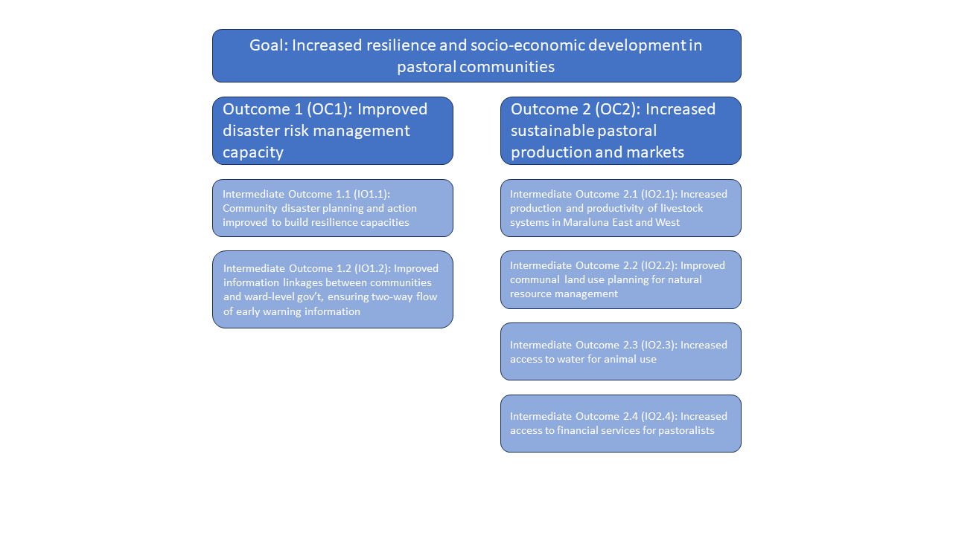

The key interventions are:

|  |
| --- |
| **Title and description of PRI’s key interventions** |
| 1. Support to Community Disaster Risk Management Plans   PRI will build household and community resilience capacities by supporting a government-led community-level analysis, planning, and action related to disaster risk management (DRM) and climate change adaptation, helping to improve community adaptation to changing climate. |
| 1. Improved communication structures for early warning information   To ensure that early warning information is shared in a coordinated approach, PRI will strengthen communication mechanisms between communities and different administrative levels of government. PRI will map and analyze how early warning systems (EWS) and conflict information is generated and disseminated to inform wider system reforms. PRI’s approach is to ensure that DRM information flows are two-way and that information is shared in a timely manner based on important calendar dates related to seasonal events; for example, pre- and post-rainy season. |
| 1. Capacity development of target groups for improved knowledge, skills and practices for productive, climate-smart, conflict-sensitive and nutrition-supporting livestock production   Taking a markets systems approach, PRI will work with key actors within the government, private sector and communities to help build capacity and create an enabling environment for market growth. Capacity Building: PRI will work with regional Agricultural/Pastoralist Bureaus to develop contextualized gender transformative pastoralist extension services manual on three key subjects: production, feed and pasture/rangeland management. PRI will support government efforts to strengthen and operationalize pastoral field schools as a key modality to deliver pastoral extension services. |
| 1. Pastoralists and agro-pastoralists access and utilize market-driven animal health and breeding services for resilient livestock production.   With rangeland fragmentation and degradation increasing over the past decade, inputs and services are of growing importance to livestock producers. PRI will develop the entrepreneurship skills of a network of community animal health workers (CAHWs) and veterinarians and act as last mile service provider to link pastoralists living in remote areas with the veterinary outlets, who will in turn support the CAHWs veterinarians. PRI will also link that network of last mile service providers to financial institutions. |
| 1. Rangeland management improved for sustained production   PRI will support multi-purpose rangeland management (land use) plans, as well as to strengthen customary institutions, such as Rangeland Councils, to implement those plans and work across communities, including a focus on reducing natural resource-based conflict. PRI will ensure that land rights and land productivity activities are underpinned by resilience thinking and conflict-sensitive practices. Activities will include representation across political, ethnic, and other identity groups so that decisions made around tenure and access to rangeland and water resources are informed by all relevant stakeholders and will be more likely to have broad support and be sustainable. |
| 1. Access to water sources is improved for livestock consumption   PRI will approach water access for livestock consumption through support and improvement of formal and informal water governance systems including exploring the role of private sector actors. PRI will work with an estimated two private sector actors to develop businesses and plans focused on the commercialization of water, alongside facilitating implementation of strategies that build systems and management arrangements that ensure access for women. PRI will pilot water commercialization on existing small-scale water facilities. Second, support will be given for improving water governance systems for existing water sources, including micro-dams and boreholes, with special attention to mitigating for potential conflicts and environmental impacts. |
| 1. Improved access to financial services for pastoralists   Tailored financial products and services for households and market actors will be developed to help provide the capital necessary for investment and day-to-day operational needs. PRI will explore the cost-benefit of government coverage of insurance premiums for pastoralists, in addition to exploring how insurance plans can layer onto traditional insurance |

**2) Impact Evaluation Purpose and Objectives**

The purpose of this impact evaluation is to evaluate the effectiveness of PRI interventions on achieving increased resilience and socio-economic development of pastoral households and communities. Mercy Corps is looking for an evaluation partner that can design and implement a robust impact evaluation. The impact evaluation design will be finalized during a three-month start-up phase (Oct-Dec 2023) and the baseline for PRI will be conducted from January 2024. During the start-up phase, a detailed implementation plan will be co-developed with the selected evaluator(s).

Successful candidates must submit a draft impact evaluation methodology, as well as the process by which they will refine the evaluation approach, and key information and decisions needed to finalize the impact evaluation design.

The Specific objectives of the impact evaluation are to:

1. Rigorously evaluate the combined impact of PRI activities to attribute change in key outcome indicators of interest to PRI interventions based on a comparison group through an experimental or quasi-experimental impact evaluation
2. Test relative effectiveness of specific combinations of activities to determine whether there are increases in effectiveness or efficiency of combined activities.
3. Determine whether certain groups benefit differentially relative to other groups – i.e. do PRI interventions have a similar impact across different types of households, marginalized groups, female headed households, etc.

|  |
| --- |
| **PRI key outcomes indicators of interest for the impact evaluation** |
| Impact indicators   * Household food security * Total household income * Household income from livestock production * Household ability to respond and recover from shocks |
| Intermediate outcome indicators   * % of households aware of community DRM * Livestock production * Access to water for animal use * Access to financial services |

|  |
| --- |
| Do not copy and paste these objectives into your technical proposal. You need only to refer to this SOW if you wish to refer to the objectives (e.g. to achieve objectives 1, 2 or 3 in the SOW, we propose …....) |

**3) Relevant Documents**

The following documents will be made available to the successful firm within 3 days of signing the contract

1. Indicator Performance Tracking Table
2. PRI’s indicator plan
3. PRI’s logframe
4. PRI’s Results Framework
5. PRI’s draft work plans
6. Planned formative assessments conducted during the life of the program.
7. Other documents needed to achieve the objectives in this SOW.

**4) Impact Evaluation Design and methods**

The methodology for conducting the impact evaluation must rely on an experimental or quasi-experimental impact evaluation design and include a baseline and endline survey. Survey instruments must be drafted by the evaluators and include at a minimum the outcome indicators listed above, as well as any other relevant covariates determined by the evaluators and Mercy Corps.

The sample size should be based on a power analysis using realistic minimum detectable effects for approximately three years of treatment. Evaluators are asked to provide one illustrative power calculation for any of the outcomes mentioned above, stating any parameters and assumptions they are making. Evaluators should also outline how they intend to determine the finale sample size. Evaluators must describe what their specific identification strategy will be to estimate impact and provide at least one illustrative estimation model.

Evaluators must use widely accepted quantitative analysis software (Stata, R, or SPSS).

**5) What Mercy Corps will provide**

èMercy Corps will provide all phones, tablets and required software (Mercy Corps has subscriptions to SPSS, Stata, MaxQDA, Commcare, Atlas.ti, Ona all of which can be used by the firm for the duration of this evaluation)

èMercy Corps will provide all vehicles needed for data collection with the fuel and driver (and salary and per diem for the driver). Each vehicle can carry 4 people (in addition to the driver) comfortably. They are 4X4 vehicles. The firm need only indicate in their proposal how many vehicles will be needed and for how many days.

è PRI’s MEL team’s 2 MEL Managers, 6 MEL officers will all be available for the duration of the evaluation to help with training and supervision of the data collectors and data management as the data are being collected. Mercy Corps will pay for these six people’s (MEL team) salary and per diem.

èMercy Corps can help the firm make reservations at hotels for the data collectors they need only know the number of data collectors and supervisors that your firm will hire.

èMercy Corps has an office with a conference room large enough to train up to 30 data collectors and that will be available to the firm.

è Mercy Corps will pay for all translation.

**6. Data Quality, Security and protection of human subjects.**

Quality of data should not be compromised, and maximum care should be taken to avoid or at least minimize errors at all stages of data collection. How the protection of personal identifying information (PII) and participants safety and well-being (human subject protection) must be described also in the technical proposal.

**7. Communication of findings/reflections.**

A final report must be submitted, and the firm must organize and facilitate a (remote) presentation of the findings to the PRI team and other Mercy Corps employees and partners as Mercy Corps deems appropriate.

**8. Team composition.**

The firm must propose a cost-effective team for this evaluation. The role of team members should be described in section II (the technical proposal) but each team member should be listed by position/function in section III (the “LOE proposal”). Please note that the proposed team composition **does not need to match or include the two roles described in the CV Submissions section** – the two profiles described in section 9 are only for CV submissions.

**9. CV Submissions**

Please submit one CV of a current staff member for the two roles listed below (2 CVs in total maximum). **Please use the provided CV template**. Firms should submit the staff members that they feel are best qualified for this project. **CV submissions do not need to match the roles or staff described in the ‘LOE Proposal’ section.** Please submit the following CVs:

1. Senior-level Project Lead / Specialist
2. Mid-level Researcher / Analyst

**10. Level of Effort for Budgeting considerations.**

Because Jalanda is a fictitious country, choose one - and only one – of the reference countries listed below as the basis for your LOE proposal for this mock SOW; sections D and E. You cannot choose a country in which your firm has its’ headquarters. Choosing a country does not mean that you have or could conduct work in that country.

|  |
| --- |
| Reference countries (select only one) |
| 1. Guatemala |
| 1. Colombia |
| 1. Burkina Faso |
| 1. Senegal |
| 1. Uganda |
| 1. Ethiopia |
| 1. Iraq |
| 1. Afghanistan |
| 1. Nepal |
| 1. Indonesia |

**10. Timeline**

The firm should propose a high-level timeline for completing this evaluation and submitting the final report on or before 31 September 2026. The timeline proposed must be consistent with the resources allocated within the technical and LOE sections of the proposals.

**11. Deliverables**

* Inception report
* Impact evaluation protocol
  + Analysis plan
  + Evaluation instruments
* Raw and analytic data sets properly documented and protected.
* Draft1 Report
* Draft2 Report
* Final Report.

èReports can be in English, French, Spanish, Arabic or Russian, Translation to English will be paid by Mercy Corps. Be sure to state, in section II (the technical proposal), in which of these languages your firm will submit the inception, draft and final reports and the evaluation instruments.

èMercy Corps will provide consolidated feedback on Draft1 report provided that report is complete and submitted as if was a final (i.e. not a “rough draft and not with any sections missing other than the annexes). Draft2 will have taken Mercy Corps feedback into account and Mercy Corps will then provide its final consolidated feedback allowing the firm to submit the final report. Thus, there are only two rounds of revisions to the report.

**11. Illustrative structure of the final report**

1. Cover page
2. Executive summary
3. Introduction
4. Background
   1. Brief description of the country/region in which the program is implemented
   2. Presentation of the program’s Logic Model
   3. Description of the program’s intervention package and assumptions
5. Methodology
   1. Identification strategy
   2. Sampling
   3. Analytical approach
   4. Limitations and challenges
6. Impact evaluation results
7. Discussion of results
8. Conclusions and lessons learned
9. Annexes