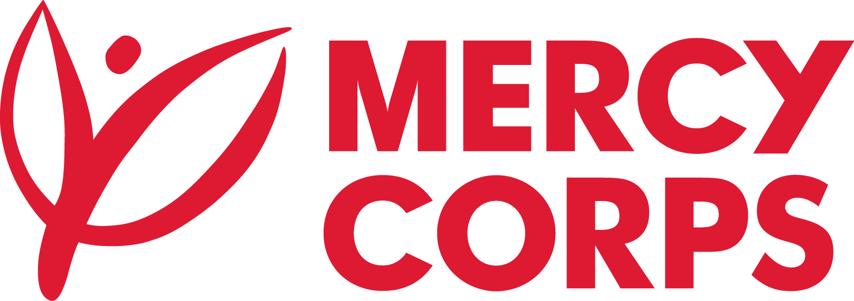
Date:18/07/2023
Reference: No. ADD 2350/2023
Tender Notice
Mercy Corps is a non-religious, non-profit, and non-governmental international humanitarian organization.

Mercy Corps invites National and International consultancy service providers to submit proposal and bid for the provision of Outcome Harvesting Consultancy service to Strengthened Socio-Economic Development and Better Employment Opportunities for Refugees and Host Communities in the Fafan Zone, Somali Region Ethiopia (STEDE) Program. The location of the project is Somali region of Ethiopia specifically located at Kebribeyah, and Jigjiga including three refugee camps of Awbare, Shader and Kebribeyah refugee camps.
If you are interested in submitting a proposal, you should complete an Intent to Bid Form and submit it according to the guidelines below.
- Suppliers can download the Intent to Bid Form from www.mercycorps.org/tenders
- Intend to Bid Form can be picked up from Mercy Corps Addis Ababa office Yeka Sub-City, Kebele 08, House No. 377; Hayahulet, Tel. 011-1-110777
- Bidders can send email to et-tender-questions@mercycorps.org and request the Intent to bid form.
Completed Intent to Bid Forms must be submitted to Mercy Corps till 24th July 2023 5:00PM in one of the below methods.
- Email completed Intent to Bid Form to et-tender-questions@mercycorps.org with the Tender Reference number in the email subject line.
OR
- Return the completed Intent to Bid Form in person and put in the Tender Box placed at Mercy Corps Addis Ababa office Yeka Sub-City, Kebele 08, House No. 377; Hayahulet. The Tender Reference number should be written on the envelope or on the email.
After the closing date of this Tender Notice, the Request for Proposal will be sent to the suppliers who submitted Intent to Bid Forms and it will be sent according to the preference you have mentioned in the Intent to Bid Form.

