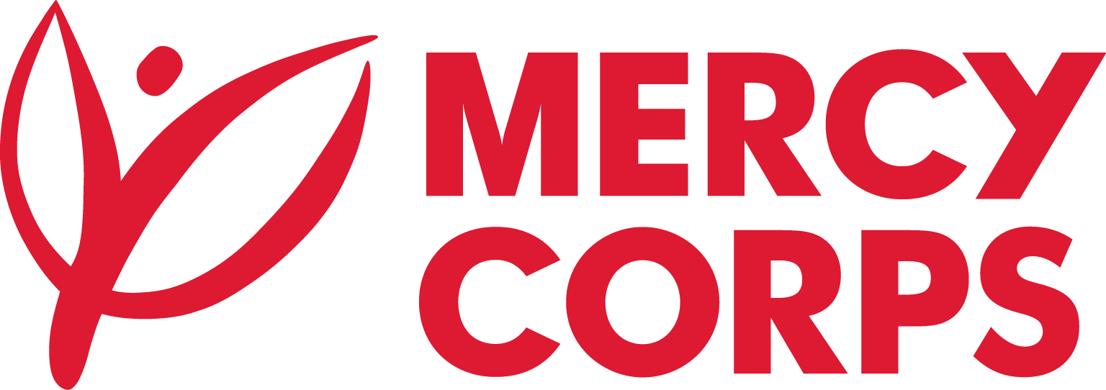
Date:10/6/2023
Reference: No. JIJ-1289/2022

Tender Notice
Mercy Corps is a non-religious, non-profit and non-governmental international humanitarian organization.

Mercy Corps is seeking a supplier to provide water treatment machine which produces 18.5m3/hr (Used to treat hard and saline groundwater to be usable for crop irrigation purposes). The project is located 2km away from Jigjiga town and in Agri-Business compound.

If you are interested in submitting a bid, you should complete an Intent to Bid Form and submit it according to the guidelines below.
- Suppliers can download the Intent to Bid Form from www.mercycorps.org/tenders
OR
- Intend to Bid Form can be picked up from Mercy Corps Addis Ababa office Yeka Sub-City, Kebele 08, House No. 377; Hayahulet, Tel. 011-1-110777
OR from Mercy corps Jigjiga office Kebele 06, House No.2079, Tel.No.+251-25-775-7477

- Bidders can send email to et-tender-questions@mercycorps.org and request the Intent to bid form.
Completed Intent to Bid Forms must be submitted to Mercy Corps till 15th June 2023 5:00PM in one of the below methods.
- Email completed Intent to Bid Form to et-tender-questions@mercycorps.org with the Tender Reference number in the email subject line.
OR
- Return the completed Intent to Bid Form in person and put in the Tender Box placed at Mercy Corps Addis Ababa office Yeka Sub-City, Kebele 08, House No. 377; Hayahulet. The Tender Reference number should be written in the envelope.
After the closing date of this Tender Notice, the Request for Bid will be sent to the suppliers who submitted Intent to Bid Forms. The Request for Bid will be sent according to the preference you have mentioned in the Intent to Bid Form.

