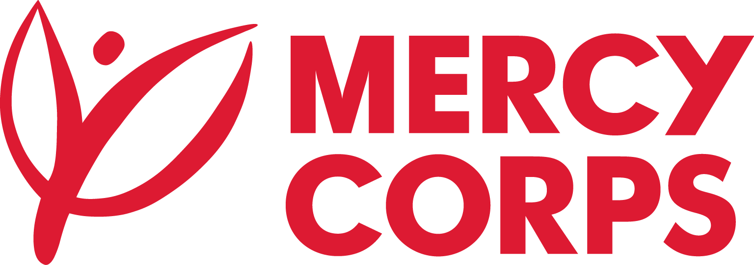

Date: 13-June-2023
Reference: MCK-NBO-WTR WRKS-023-010
TENDER NOTICE
Mercy Corps is a non-religious, non-profit and non-governmental international humanitarian organization.

Mercy Corps is seeking suppliers to do rehabilitation works for Proposed Ngilai Elbarta, Loluko and Nachola Water Systems. The projects are in Samburu County.

If you are interested in submitting a bid, you will need to complete an Intent to Bid Form and submit it according to the guidelines below.
- Suppliers can download the Intent to Bid Form at https://www.mercycorps.org/tenders
Completed Intent to Bid Forms must be submitted to Mercy Corps by 19th June 2023 @17:00hrs according to the guidelines below.
- Email completed Intent to Bid Form to ke-bids@mercycorps.org with the Tender Reference number (MCK-NBO-WTR WRKS-023-010) in the email subject line
After the closing date of this Tender Notice, the Request for Bid will be sent to the suppliers who submitted Intent to Bid Forms. The Request for Bid will be sent according to the preference you have mentioned in the Intent to Bid Form.

