McGovern-Dole Food for Education and Child Nutrition Program in Uzbekistan

Mercy Corps Uzbekistan

Scope of Work

Baseline Assessment for Phases II and III

Context

The Government of Uzbekistan issued a reform agenda to improve education and health outcomes, focusing mostly on its youth population. Despite significant economic development over the last decade, approximately 12 percent of the population lives below the poverty line, of which 75 percent are rural dwellers. The COVID‑19 pandemic drove an additional half-million people into poverty as exports and remittances fell, and employment insecurity increased, especially among young entrepreneurs and small business owners.

Upon gaining independence, the Government of Uzbekistan inherited a severe environmental crisis. Intensive irrigation during the Soviet period, combined with climate change, has devastated the Aral Sea. This ecological disaster is draining local economies of their livelihoods and wiping out fishing industries that once dominated the region. Crop damage and increased air and water pollution are causing severe health consequences in the region, particularly among women and children. Anemia and respiratory illness among children is particularly high as a result of pollution and poor nutrition.

In addition to health and malnutrition risks, children in Uzbekistan lack access to quality early childhood education. While strides have been made in urban centers, enrollment remains disproportionately lower in rural areas. In preparation for a demographic boom and the need for youth job creation, the Government of Uzbekistan is investing in children and young people. Improving the education sector, and in particular early childhood education, will help build the foundation needed to facilitate growth and job creation.

Pre-primary education (preschool) covers children ages 3-7, with the final year of preschool prior to entering Grade 1 now mandatory as of the 2020-2021 school year per national legislation. The new requirement and the increasing demographic realities of children under seven across the country will put significant pressure on the educational system in the coming years. This is especially true given the number of preschools in Uzbekistan decreasing markedly over the past 20 years by almost half (- 45%) with only 818,000 out of 2,450,000 children accessing preschool education as of 2017. This figure has improved though and as of 2021, 62.4% of children were enrolled of the 2,800,000 eligible. Access to quality pre-primary education remains a challenge, particularly in rural and under-resourced areas. Official statistics from 2021 show enrollment of 74.2% in the Republic of Karakalpakstan and 45.1% in Surkhandarya. Additionally, evidence suggests that nutritional deficiencies leave preschool children vulnerable to poor cognitive and physical development, impeding their ability to learn and thrive. For that reason, meals in preschools are one of the most effective incentives for families to send their children back to preschool.

USDA McGovern-Dole Food for Education and Child Nutrition program in Uzbekistan, implemented by Mercy Corps, addresses these challenges by providing students in targeted preschools with a strong foundation in reading, nutrition and health interventions and improving literacy. This holistic investment in young children increases their likelihood of future academic and workforce success. Children’s environments and experiences during early childhood shape their developing brains, influence what knowledge, skills and attitudes they bring with them to school, and determine their trajectory for success in school and life. As adequate nutrition is a fundamental part of healthy growth and better educational performance, the program also includes health and nutrition-sensitive activities such as the use of micronutrient-fortified food products, water, sanitation and hygiene (WASH) projects, and curriculum-based nutrition education.

Program Summary

Mercy Corps is a leading global organization powered by the belief that a better world is possible. In disaster, in hardship, in more than 40 countries around the world, we partner to put bold solutions into action — helping people triumph over adversity and build stronger communities from within.

The USDA McGovern-Dole International Food for Education and Child Nutrition program in Uzbekistan will target 294 preschools in the Republic of Karakalpakstan and Surkhandarya Region reaching over 40,000 children of 3-7 years old enrolled in the target preschools. The objectives of the program are to:
- Improve student attendance in preschools through the provision of daily preschool meals, improved learning environment, and access to clean water and sanitation;
- Promote reading readiness in preschools through the provision of age-appropriate pre-literacy activities, training and mentoring of preschool teachers and administrators on pre-literacy instruction and enhancing community and family support for reading;
- Improve preschool infrastructure and the learning environment of preschool children through the construction or rehabilitation of preschool kitchens, classrooms and water and sanitation facilities;
- Increase knowledge of nutrition, health, and hygiene practices and safe food preparation and storage practices, by facilitating training for cooks, nurses and information sessions for parents.
The program implementation takes place from October 1, 2019 to September 30, 2024. The implementation targets a total of 294 preschools that will be enrolled in the program for two years. For that reason, program implementation is divided into three phases during which preschools will be enrolled. Phase I will target 60 preschools, phase II will target 160 preschools (including 60 preschools continuing from phase I in addition to 100 newly enrolled preschools). Phase III will target a total of 234 preschools (100 continuing preschools from phase II in addition to 134 newly enrolled preschools).

Purpose of the Baseline Assessment for Phases II and III

For Phases II and III, Mercy Corps will recruit a consulting entity to conduct a baseline assessment for all newly 234 enrolled preschools. The baseline assessment will serve two main purposes:
- It will provide baseline values for several key program performance indicators (please see Table 1 for the list of indicators and suggested data collection tools);
- It will serve as a tailored needs assessment focusing on infrastructure facilities, preschool staff capacity, household practices and parental perspectives for each preschool entering the program to help guide program intervention (please see Table 2 for the details on topics and suggested data collection methods).
Research questions
- What are the baseline values for key performance indicators on student attendance, enrollment, preschools with improved water sources and sanitary facilities, and children’s reading readiness?
- What is the technical condition of key infrastructure facilities on water sources, sanitation, handwashing, kitchen rooms and kitchen equipment?
- How well do preschool cooks and nurses know their responsibilities as per the national standards?
- What are the household practices on food consumption, food storage, health and hygiene?
- What kind of literacy resources are available in the family? What are the family practices to engage their children in learning? What are the parental views on their children’s skills in health, hygiene and nutrition?
This baseline is a core part of the monitoring and evaluation plan for this program, including a midterm and a final performance evaluation with no counterfactual. The indicator values established through this baseline will be used for analysis of program effectiveness in both midterm and final evaluations.
Table 1: Key Program Performance Indicators to be Assessed and Suggested Tools
Indicator | Suggested Data Collection Method
MGD Indicator 2. Average student attendance rate in USDA supported classrooms/schools | Document review of preschool attendance records
MGD Indicator 3. Number of students enrolled in schools receiving USDA assistance | Document review of preschool enrollment records
MGD Indicator 27. Number of schools using an improved water source | Infrastructure assessment tool, 1 preschool
MGD Indicator 28. Number of schools with improved sanitary facilities
Custom Indicator. Percent of preschool children with acceptable score on reading readiness assessment during final year | Children’s direct assessment tool, 10-20 children per preschool

Table 2: Phase II and III Needs Assessment Topics and Suggested Tools
Mercy Corps has adjusted the data collection tools to the purposes of the second and third phases based on the experience and lessons learned from the first phase conducted in the spring of 2022. Almost all of the tools are close to the finalization stage and will require the consultant to review and propose necessary changes to improve their quality.
Topic | Suggested Data Collection Methods and Tools | Status of Data Collection Tools
Preschool infrastructure facilities
- Infrastructure base and needs  - Type of water source  - Type of sanitation facilities  - Handwashing facilities  - Kitchen equipment and rooms | - Infrastructure assessment tool | - Infrastructure assessment tool was finalized and requires coding for Ona/ODK only.
Preschool staff capacity
- Knowledge of nurses  - Knowledge of cooks | - Knowledge assessment tool for nurses, 1 nurse per preschool  - Knowledge assessment tool for cooks, 1 cook per preschool | - Knowledge assessment tools for nurses and cooks was adapted from the original version and requires minor revisions. Coding for Ona/ODK is required.
Household practices
- Food consumption  - Food storage  - Health, hygiene and nutrition | - Nutrition, food storage and hygiene questionnaire, 2-3 parents per preschool | - Nutrition, food storage and hygiene questionnaire was adapted from the original version and requires minor revisions. Coding for Ona/ODK is required.
Home environment and parental views
- Availability of literacy resources in the family  - Family practices on home learning for children  - Parental views on children’s skills in health, hygiene and nutrition | - Parent/caregiver report questionnaire | - Parent/caregiver report questionnaire was adapted from the original version and requires minor revisions. Coding for Ona/ODK is required.
Gender is a cross-cutting theme for all Mercy Corps assessments. As a minimum standard, all data will be disaggregated by age and gender. In addition, Mercy Corps and the selected data collection company will work together to identify appropriate questions and data collection techniques for the gender-specific questions in the data collection tools listed above. The objective is to assess and understand the differences in the lives of women and men (parents and teachers), girls and boys, and to ensure they are equitably engaged as active stakeholders during the program. Furthermore, the analysis will examine the power relationships between and among these groups.
Consultant’s Responsibilities and Tasks
Consultant’s tasks include:
- Prepare the baseline assessment work plan in consultation with M&E Manager.
- Review of data collection tools proposed by Mercy Corps and provide input and modifications to them, except the tools on infrastructure assessment, preschool attendance and enrollment records. Data collection for these tools will be conducted by Mercy Corps, but the data analysis and reporting will be conducted by the consultant.
- Translate revised data collection tools to Russian, Uzbek, and Karakalpak with the feedback from Mercy Corps.
- After the tools are finalized and translated, the consultant will digitize the structured tools for mobile data collection. Mercy Corps preferred digital data collection platform is Ona. For the digital tools and other relevant data sources, the consultant will develop suitable databases and data entry protocols.
- Recruit and engage a team of experienced enumerators, consisting of residents from the regions in which data is being collected, to enable ease of access and responsiveness of participants. Preference should be given to those who have previously conducted similar assessments or research projects.
- Training of enumerators: Upon engagement of the enumerators, the consultant together with Mercy Corps will develop and deliver the training for all assessment team members to ensure a shared understanding of the objectives of the assessment, tools and questions, data collection techniques and expected deliverables. The training must include a field practice exercise to pilot the data collection tools and field protocol.
- Piloting and testing of tools: After the training of enumerators, the consultant will conduct piloting to test the validity of data collection tools in the preschool setting.
- Field work: Field work will take place in the target two regions, Karakalpakstan and Surkhandarya, Preference will be given to concurrent data collection in both regions.
- Data quality: The consultant will do spot checks of data and use other quality data assurance methods. Additional data collection of missing or inaccurate data will be done if necessary.
- The consultant will provide a clean and verified database to Mercy Corps, including translation into Russian and English.
- Data analysis and reporting: The consultant will analyze the collected data and data charts to consequently generate the baseline assessment report based on the agreed upon structure in English.
- Assessment report: The consultant will first write the English version of the report and then provide a translation into Russian after acceptance and finalization of the original English-language version.
Baseline Assessment Timeline
Activity | Stakeholder | Tentative Timeline
Publish TOR and receive applications from data collection companies | P&L | December 2022
Review applications, interview and select a data collection company to conduct baseline data collection | Tender Committee | February 2023
Facilitate and secure approvals and permits | COP | February 2023
Review data collection tools and submit Inception Report to Mercy Corps | Data Collection Company | March 2023
Translate and digitize data collection tools | M&E, Data Collection Company | March 2023
Train enumerators, pilot and finalize data collection instruments | M&E, Data Collection Company | April 2023
Collect data in target 234 preschools | Data Collection Company | May – June 2023
Clean and verify data | Data Collection Company | June 2023
Conduct data analysis | M&E, Data Collection Company | June 2023
Prepare draft baseline report and submit to Mercy Corps | M&E Manager, HQ | July 2023
Baseline report review and finalization | M&E, Program teams, HQ | August 2023
Report submission to USDA | COP, HQ | August 2023
Finalize report based on USDA feedback | M&E, Data Collection Company | September 2023

Deliverables

Ten deliverables are foreseen under the consultancy. They include:
- English-language inception report (5 % of total contract price) to be submitted two weeks after signing the contract. This will present:
- Improvements made to the data collection tools and questions,
- Data collection and quality assurance plan,
- Finalized work plan for the baseline assessment.
- Translation into Russian, Uzbek, Karakalpak and digitized data collection tools (10% of total contract price): excel files in machine-readable format (XLS) should be submitted to Mercy Corps in two weeks after submitting the inception report.
- Pilot report in English (5% of total contract price): description of piloting of data collection tools; one preschool from the sample of target preschools will be selected to test and correct the tools.
- Fieldwork report in English (10% of total contract price): description of field work activities focusing on data collection activities in all preschools, issues encountered, solutions proposed, a set of recommendations and lessons learned for the next round of data collection.
- Cleaned datasets with raw data in English and Russian (10% of total contract price) to be submitted in one week after submitting the fieldwork report.
- Presentation of preliminary results in English. Report plan (10% of total contract price) to be submitted in two weeks after submitting the fieldwork report.
- Draft Report in English (20% of total contract price): This is due no later than three weeks of the fieldwork report submission. The report will present the executive summary, analysis of findings of the baseline assessment and practical recommendations on program implementation, M&E Plan and PMP. The format for the draft report will be agreed with Mercy Corps at the outset of the consultancy.
- Clean excel files with all data charts generated for the production of assessment report. This needs to be submitted together with the draft report.
- Final Report in English (20% of total contract price): The consultant will produce the final report, taking into consideration comments from the Mercy Corps team (first draft) and USDA (second draft). The final report will need to be edited for publication in compliance USDA requirements on protecting personal data, including Personally Identifiable Information (PII) and be Section 508 compliant.
- Translation of final report in Russian (10% of total contract price): Translated version should be of excellent quality and presentable to external audiences.

Consultant Management

The consultant will report to the M&E Manager and work closely with the M&E and program teams in Mercy Corps Uzbekistan. M&E Manager will monitor and track progress of the various activities under the consultancy.

To support the consultant in carrying out the tasks outlined above, Mercy Corps will provide the following:

- All relevant program documents, including program design documents, M&E Plan, PMP, program reports, workplan, Mercy Corps M&E requirements on age/gender and USDA indicator handbook
- Data collection tools designed and used by Mercy Corps during Phase I Baseline
- Required permissions and letters of support for the Government of Uzbekistan
- Recommendations on available data collection companies or enumerators
- Technical support from Mercy Corps Uzbekistan and HQ experts, where needed.

Required Skills, Experiences and Competences

Mercy Corps is looking for a consulting entity that can provide a team with the following requirements:

  - A highly experienced team leader to manage the overall process and lead methodology development, analysis and reporting:
- A masters’ degree qualification from a recognized university in any of the following areas: sociology, development studies, education, health, nutrition or any other relevant field
- Demonstrable experience in leading teams in designing and conducting assessments or research projects in Uzbekistan and/or Central Asia, preferably for similar international programs
- Fluent in English and Russian with a proven ability to write reports in both languages. Uzbek language skills are desired.
- Solid methodological and research skills, qualitative and quantitative, demonstrated through a list of research pieces and evaluations
- Previous experience with standard international literacy tools, such as MELQO, IDELA, EGRA
- In-depth knowledge of the socio-cultural, economic and political context of Uzbekistan, especially the target regions
- Excellent report writing skills, demonstrated by a list of published articles or reports
- Excellent analytical interpersonal and communications skills

  - An analyst / statistician / digital data collection expert
- A degree in statistics, data analysis, economics, social sciences or other relevant field
- Significant experience conducting surveys, baseline assessments and research studies
- Experience of analyzing qualitative and quantitative data using statistical software
- Solid experience with designing survey questionnaires
- Solid experience with designing questionnaires using mobile data collection tools (ONA, ODK)
- Fluent in English and Russian with a proven ability to write reports in both languages. Uzbek and Karakalpak language skills are desired.

  - A team of experienced enumerators for the health, hygiene and nutrition assessment with the following qualifications:
- Minimum 2-3 years of direct field data collection experience with qualitative and quantitative tools
- Educational and/or professional background as nurses and cooks in a preschool setting
- Fluency in spoken Uzbek and Karakalpak; proficiency in Russian is desired
- Direct experience with mobile-based data collection platforms (Ona, ODK) on tablets and/or smart phones
- Attention to detail and ability to follow strict data collection protocols
- Knowledge of Uzbek government standards on health, hygiene and nutrition in preschools
- excellent interpersonal skills (positive attitude, teamwork, communication, listening)

  - A team of enumerators for the pre-literacy assessment with a specific background and/or expertise in literacy-related measurements with the following qualifications:
- Minimum 2-3 years of direct field data collection experience with qualitative and quantitative tools
- Educational and/or professional background in education, preferably at the preschool or primary school level (teachers, assistant teacher, librarians, etc.)
- Fluency in spoken Uzbek and Karakalpak; proficiency in Russian is desired
- Direct experience with mobile-based data collection platforms (Ona, ODK) on tablets and/or smart phones
- Attention to detail and ability to follow strict data collection protocols
- Previous experience with standard international literacy tools, such as MELQO, IDELA, EGRA is desired
- Previous experience with and knowledge of main concepts of working with preschool children
- excellent interpersonal skills (positive attitude, teamwork, communication, listening)

  - Supporting team members as needed (translation, data entry, transcription and note taking, etc.).
Proposal Submission

An Offeror may submit a proposal covering either the full scope of services and tasks or selected services and tasks included in this Scope of Work. The proposed scope must be clearly described in the technical proposal. The proposal must be submitted in the English language.

The proposal must be submitted in electronic form at tenders@mercycorps.org by February 17, 2023, 18:00 (Tashkent time). All proposal questions must be submitted in writing at uz-pro@mercycorps.org by January 27, 2023, 18:00 (Tashkent time). The answers will be provided by February 3, 2023, by 18:00 (Tashkent time).

Technical proposal must include:
- Two to three pages narrative describing the following:
- Proposed scope of services and tasks as per the Scope of Work
- Proposed partnership if any
- Proposed data quality assurance mechanism
- Experience with mobile-based data collection platforms (Ona, ODK) on tablets and/or smartphones
- Proposed mobilization and training strategy for enumerators
- CVs of key personnel, 3 pages max per personnel
- List of similar projects implemented by the Offeror in the area of education, nutrition, infrastructure
- List of reports and publications produced by the Offeror in the area of education, nutrition, infrastructure
- Three samples of past research projects or reports. Mercy Corps may request additional samples.
- Three references from past clients
- Price offer based on the template below specifying all the relevant costs
Price Offer Template *
Proposed Service Type | N of Estimated Services | Price per Unit in USD including all related costs | Total Price
Coding, testing, translating and finalization of infrastructure assessment tool | ___ consultancy days
Coding, testing, translating and finalization of reading readiness assessment tool | ___ consultancy days
Coding, testing, translating and finalization of knowledge assessment tool for nurses | ___ consultancy days
Coding, testing, translating and finalization of knowledge assessment tool for cooks | ___ consultancy days
Coding, testing, translating and finalization of parent questionnaire on household practices | ___ consultancy days
Coding, testing, translating and finalization of parent/caregiver report questionnaire | ___ consultancy days
Data collection: children’s direct assessment tool, tentatively 10-20 per preschool | ___ respondents
Data collection: Knowledge assessment tool for nurses, 1 nurse per preschool | ___ respondents
Data collection: Knowledge assessment tool for cooks, 1 cook per preschool | ___ respondents
Data collection: Nutrition, food storage and hygiene questionnaire, tentatively 2-3 parents per preschool | ___ respondents
Data collection: Parent/caregiver report questionnaire | ___ respondents
Preparation of inception report | ___ consultancy days
Preparation of pilot report | ___ consultancy days
Preparation of fieldwork report | ___ consultancy days
Preparation of cleaned datasets | ___ consultancy days
Presentation of preliminary results | ___ consultancy days
Preparation of draft report | ___ consultancy days
Preparing final report | ___ consultancy days
Translation of final report | ___ consultancy days

* Note: An Offeror may expand the template to add other relevant costs.

Evaluation Criteria

Trade-Off Method

Mercy Corps Tender Committee will conduct a technical evaluation which will grade technical criteria on a weighted basis (each criterion is given a percentage, all together equaling 100%). Offeror's proposals should consist of all required technical submittals so a Mercy Corps committee can thoroughly evaluate the technical criteria listed herein and assign points based on the strength of a technical submission.

Award criteria shall be based on the proposal’s overall “value for money” (quality, cost, etc.) while taking into consideration donor and internal requirements and regulations. Each individual criterion has been assigned a weighting prior to the release of this tender based on its importance to Mercy Corps in this process.

Offeror(s) with the best score(s) will be accepted as the winning offeror(s), assuming the price is deemed fair and reasonable and subject to the additional due diligence in section 3.5.2.

When performing the Scoring Evaluation, the Mercy Corps tender committee will assign points for each criterion based on the following scale:

Point | Rationale
0 | Not acceptable; has not met any part of the specified criteria
1-4 | Has met only some minimum requirements and may not be acceptable
5 | Acceptable
6-9 | Acceptable; has met all requirements and exceeds some
10 | Acceptable; has exceeded all requirements

Evaluation Criteria | Weight  (%) | Points  (1-10) | Weighted Points
 | A | B | (A*B)
Offeror’s ability to provide key personnel and enumerators with the necessary qualifications | 25%
Data collection experience for relevant projects in Central Asia and/or Uzbekistan | 15%
Data collection experience in public pre-schools or schools | 10%
Price per unit | 20%
Data quality assurance mechanism | 15%
Experience with mobile-based data collection platforms (Ona, ODK) on tablets and/or smartphones | 10%
Experience with Mercy Corps and/or US Government-funded projects | 5%
Overall Score: | 100%

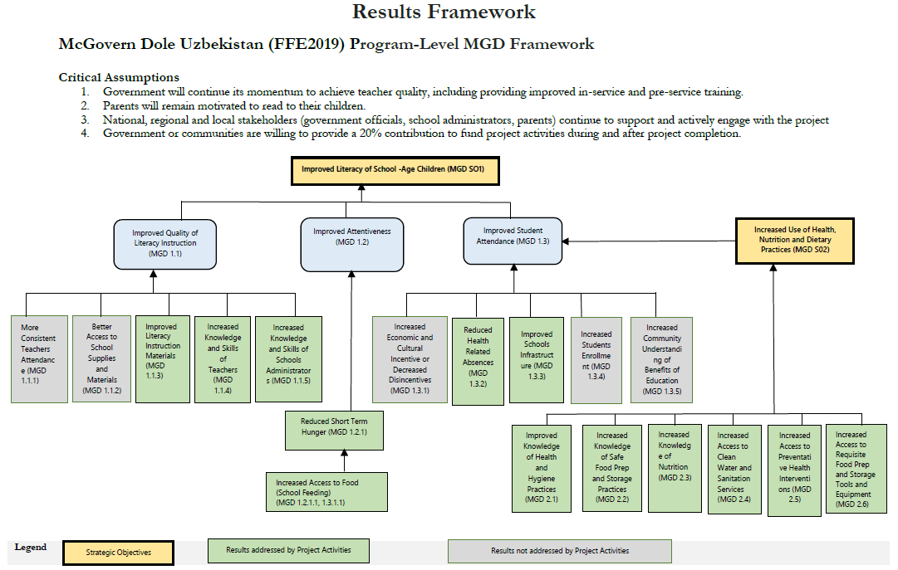

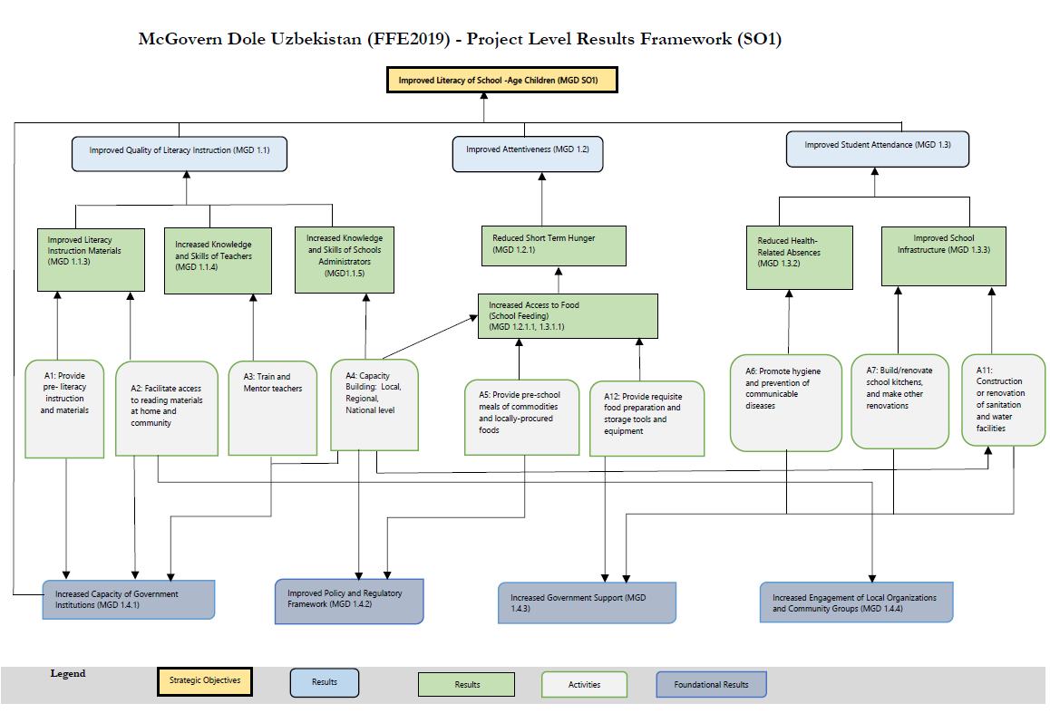

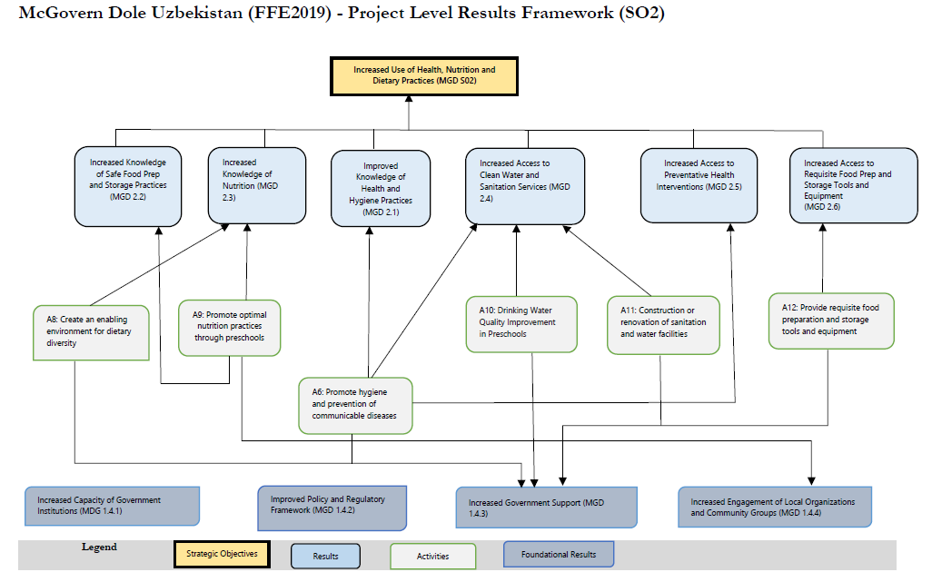

Exact sample size will be determined by the selected consulting entity in consultation with Mercy Corps
Exact sample size will be determined by the selected consulting entity in consultation with Mercy Corps
Mercy Corps and USDA will provide necessary guidance.
Exact sample size will be determined by the selected consulting entity in consultation with Mercy Corps
Exact sample size will be determined by the selected consulting entity in consultation with Mercy Corps
Exact sample size will be determined by the selected consulting entity in consultation with Mercy Corps

