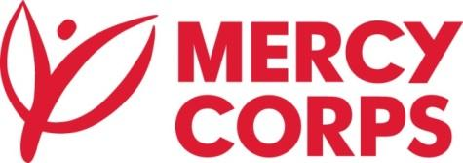

OPEN TENDER # MC-SJU-T032

Tender T032 - Master Agreement for Hotels & Conference services

Mercy Corps is a non-profit, humanitarian agency registered in Puerto Rico since 2017. We create breakthrough solutions by connecting people to the resources they need to strengthen their community from within. We are in the process of collecting proposals for rooms and conference space in Puerto Rico, for the next five years (or two years).

Registered companies can **obtain the tender documents from February 2, 2022 at 8:00 AM AST to February 11, 2022; 5:00 PM AST** via email [**pr-procurement@mercycorps.org**](mailto:pr-procurement@mercycorps.org)

**Last Date for bid submission is February 22, 2022 at 5:00 PM AST**

If any, submit questions in writing to [**pr-procurement@mercycorps.org**](mailto:pr-procurement@mercycorps.org) indicating the tender number in the subject line

Powered by the belief that a better world is possible. [mercycorps.org](https://www.mercycorps.org/)

 We're social: [facebook.com/MercyCorpsPR](http://facebook.com/MercyCorpsPR)