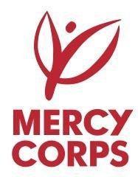
TENDER NOTICE

Description: | Request for Proposal for the Provision of Specialized Consultancy Services
Reference Number: | TL007/SA/PUA
Program: | Plastic Upcycling Alliance (PUA)
Funded by: | United States Agency for International Development (USAID)
Implemented by: | Mercy Corps
Issuance Date: | May 13, 2021
Questions Due: | May 20, 2021
Deadline for Offers: | May 27, 2021 at 23:59 Timor-Leste Local Time (GMT+9)

Mercy Corps is a non-religious, non-profit and non-governmental international humanitarian organization.
Mercy Corps is seeking a qualified Company or Organization to complete a Plastic Upcycling Market and Economic Analysis for Mercy Corps in Timor-Leste.
Tender documents can be requested from May 12, 2021 by sending an email to:
timorleste-procurement@mercycorps.org
All questions related to this tender should be submitted until May 20, 2021 to:
timorleste-procurement@mercycorps.org
Interested parties are requested to submit their proposal via email no later than 23:59 Timor-Leste local time (GMT+9) on May 27, 2021 to:
tenders@mercycorps.org
With the subject line:
“RFP Mercy Corps - TL007/SA/PUA”
Only the offers submitted in the prescribed form and deadlines will be considered. Only legally registered firms with current tax registration will be considered.

