Request for Application

Issuance Date: 08/10/2020
Closing date for Application: 27/10/2020 at 5:00 PM Ethiopian Time
Overview
Livelihood Improvement for Women and Youth (LI-WAY) is a market development program funded by Swedish International Development Agency (SIDA) and implemented in Addis Ababa by four international consortium members; Netherland Development organization (SNV) lead, Techno Serve, Save the children international and MERCY CORPS.
The project is designed to improve the livelihood of youth and women in the urban contexts with the overall objective of the program contributing to sustainable poverty reduction. The specific objective is to improve the livelihoods situation of 200,000 poor people, of which at least 50% are women and 75% youth, by increasing their income and access to economic opportunities.
Purpose
The purpose of this RFA is to solicit Expression of Interests (EOI) from prospective awardees for implementing activities under the LI-WAY project, focused on promoting growth of two prioritised sectors which are listed below:
- Labour market: it is a supply of skilled and unskilled labour to formal and informal employers. The following closely related activities are identified to contribute for proper functioning of labour market.
Child care: A function that, if not available, may reduce the quantity and quality of mothers’ labour force participation. Women are often constrained from income-generating activities due to childcare obligations which are still predominately considered a female’s role in the household. Without access to formal through childcare service providers or domestic help or informal through family and friends affordable, trusted and flexible childcare women in Addis Ababa stay out of employment.
Job matching: The mechanisms that bring the supply of jobs and demand for jobs together that affects quantity and quality of supply and demand. A supporting market of job matching is exchange infrastructure itself meaning the platform through which people can provide job matching services. Some of the fundamental market failures include job market information irregularity, lack of information and gaps on the required skills, lack of skill even to write curriculum vitae and an application, job seekers without Addis ID, low income women and youth job seekers not able to afford service charges, and limited technological solutions for job matching.
Referencing: Verification services (character, skills, health, and criminal background) that employers require of potential employees and affects the quantity of supply. The majority of employers required character references as a precondition of employment. This is a major problem for those job seekers who come from rural areas/out of Addis since they do not have good social network. Character referencing is mandatory and the person who is going to be a reference should have Addis ID. Hence, to get those personal references, job seekers are required to pay some amount of money for their personal references and female job seekers are more vulnerable than male job seekers.

- Skills Development;

- Improving Public TVETs Leadership and Governance: Despite the efforts has been made by Government & development partners to improve Public TVETs Leadership and governance, most of public TVETs still lack good leadership and internal as well as external coordination. As result of this and other contributing factors, they are facing problem regarding building reputation, gaining acceptance by the public (TVET trainees, Family and employers), creating connection with private sectors for cooperative training and even for job linkages.
- Sensitizing Industries to Promote & Engage in Cooperative Training:
It is obvious that Successful cooperative training demands the harmony relations between stakeholders, mainly TVET institutions and Industries /companies. However, studies revealed that the implementation of cooperative training program has been highly affected by shortage of companies/Industries that host cooperative trainees due to the weak linkage between TVETS & the industries. Moreover, most of the Industries/Companies have no adequate awareness on the purposes, objectives, and the implementation process of the training; the involvement of Industries/companies in Planning, Implementing and Evaluating the training is low; and so on.
Eligible Enterprises
Who may apply for an award?
- The Applicant must be a local (indigenous) organization, defined as an entity organized or recognized in accordance with the laws of Ethiopia;
- Any formally registered private sector profit making organizations with renewed license which is proposing activities that support the objectives of the LI-WAY as identified above.
Who may not apply for an award?
- Any organization that is prevented from receiving donor and specifically SIDA funds
- Any organization which is proposing activities that do not support the objectives of the LI-WAY as identified above.
Geographic coverage: with in Addis Ababa
More Information
- Interested applicants are encouraged to collect the full application package from www.mercycorps.org/tenders from 08/10/2020 to 27/10/2020 5:00PM ;
- Application deadline is 27/10/2020 5:00 PM; and applications sent after this date may not be considered;
- Please send applications by et-tender-questions@mercycorps.org and applications sent by other email will be disqualified;

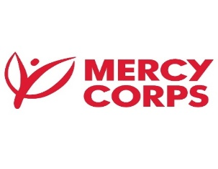
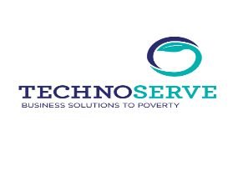
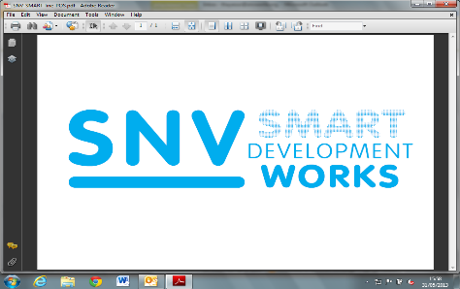
- Tirame Godebo, tgodebo@mercycorps.org can be used if there is technical questions; and only till 15th Oct. 2020;
- Failure to comply with any of the conditions indicated above will result in automatic rejection;
- Mercy Corps reserves the right to reject the bid fully or partially.

Mercy Corps Ethiopia, Country Office located at Yeka Sub-City, Kebele 08; House No. 377, Hayahulet Gollagul Square | In front of Shola Taxi station | Afro building, Telephone number +251- 11-111- 0777

