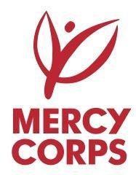

TENDER NOTICE

Mercy Corps is a non-religious, non-profit and non-governmental international humanitarian organization.

Mercy Corps is seeking interested bidders to submit their bids in response to Tender NIG/ABV/TEN20 for HMO services for the Health Insurance of its staff.

Mercy Corps is seeking qualified providers with a proven background in this area. Tender packages can be picked up from Mercy Corps Nigeria country office located at Plot 166, Umaru Dikko Street, Adjacent Lakeview Hotel, Jabi, Abuja or can be downloaded at https://www.mercycorps.org/tenders/. All questions should be submitted to questions@mercycorps.org.

Tenders must be submitted to Mercy Corps Nigeria country office located at Plot 166, Umaru Dikko Street, Adjacent Lakeview Hotel, Jabi, Abuja or send electronic copy to tenders@mercycorps.org with proposal subject “NIG/ABV/TEN20 – HMO” by October 09, 2020 closed by 5PM Nigeria time.

Only tenders submitted in prescribed form and deadlines will be considered. Only legally registered firms will be considered.
All tenders should be submitted in sealed envelopes clearly marked:

“NIG/ABV/TEN20 – HMO”

